

**Government of the People’s Republic of Bangladesh   
Ministry of Local Government, Rural Development and Co-operatives   
(Local Government Division)**

**Environmental and Social Screening Report**

**On**

**Construction of Household Single Toilet**

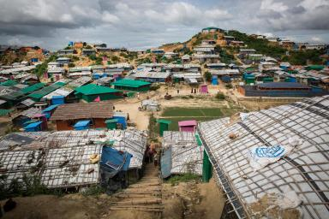

**Location: DRP Camp_17, Sub-project (Package No.): EMCRP/WD-AF-29**

**Emergency Multi-Sector Rohingya Crisis Response Project (GoB-WB)**



**Department of Public Health Engineering (DPHE)**

# Abbreviation and Acronyms

|  |  |
| --- | --- |
| ACF | Action Against Hunger |
| BBS | Bangladesh Bureau of Statistics |
| BD | Bangladesh |
| BMD | Bangladesh Meteorological Department |
| CIC | Camp in Charge |
| DC | Deputy Commissioner |
| DO | Dissolved Oxygen |
| DoF | Department of Forest |
| DPD | Deputy Project Director |
| DPHE | Department of Public Health Engineering |
| DRP | Displaced Rohingya Population |
| DTW | Deep Tubewell |
| DTTW | Deep Tara Tubewell |
| EC | Electrical Conductivity |
| EE | Executive Engineer |
| EMCRP | Emergency Multi-sector Rohingya Crisis Response Project |
| ERP | Emergency Response Plan |
| ESMF | Environmental & Social Management Framework |
| ESMP | Environmental and Social Management Plan |
| FAO | Food and Agriculture Organization |
| FGD | Community consultation |
| GBV | Gender-Based Violence |
| GoB | Government of The People’s Republic of Bangladesh |
| GRC | Grievance Redress Committee |
| GRM | Grievance Redress Mechanism |
| GPS | Global Positioning System |
| GW | Ground Water |
| HDPE | High Density Polyethylene |
| HH | Household |
| IEF | Important Environmental Feature |
| IOM | International Organization for Migration |
| ISCG | Inter Sector Coordination Group |
| IUCN | International Union for Conservation of Nature |
| NGO | Non-Government Organization |
| LGED | Local Government Engineering Department |
| PD | Project Director |
| PMU | Project Implementation Unit |
| PM | Particulate Matter |
| PMU | Project Management Unit |
| PPE | Personal Protective Equipment |
| PSC | Project Steering Committee |
| PTW | Production Tube well |
| PVC | Polyvinyl Chloride |
| ROW | Right of Way |
| RRRC | Refugee Relief and Repatriation Commission |
| SAE | Sub–Assistant Engineer |
| SMC | School Management Committee |
| SW | Surface water |
| TDS | Total Dissolved Solids |
| TSS | Total Suspended Solids |
| TTW | Test Tube Well |
| UN | United Nations |
| UNFPA | United Nations Fund for Population Activities |
| UNHCR | United Nations High Commissioner for Refugees |
| uPVC | Un plasticized Polyvinyl Chloride |
| VfM | Value for Money |
| WASH | Water, Sanitation and Hygiene |
| WB | World Bank |
| WDZ | Water Distribution Zone |
| WFP | World Food Programme |
| WSC | Women's Studies Center |

**EMCRP (DPHE part)**

**Environmental and Social Screening Form**

# Sub-Project Description Form

**Introduction:**

Under the EMCRP, DPHE will construct 3000 household toilets at different locations of DRP camps. This screening report is prepared for sites of 180 (One hundred Eighty) household toilets of Camp-17.

**Name of Sub-project:** Construction of Camp based household toilet including Operation and Maintenance Scheme under WD-AF-29 for Displaced Rohingya Population (DRP) at Ukhiya Upazila, Cox’s Bazar.

**Implementing Agency/Agencies:** Department of Public Health Engineering (DPHE)

**Estimated total cost per household toilet (in Taka):** Approximate 60,000 Taka (on average)

**Estimated construction period duration:** 12 (twelve) months.

**Estimated Operation and Maintenance period (life of sub-project):** Defects & Liabilities period of household toilet is 12 (twelve) months but the design life of each toilet is five years.

**District:** Cox’s Bazar **Sub-District:** Ukhiya **Union:** Palongkhali

**Name of Community/Local Area:** Camp-17, Block- A, B and C.

**Description of proposed sub-project activities *(incl. type of activities, footprint area, natural resources required, etc.):***

**Subproject Activities:**

To implement the proposed subproject intervention following tentative activates to be performed at sub-project areas

* Site selection (already done), site cleaning, earth excavation, brick work, ring pits placement, placement of long pan with U trap, etc. For household toilet 2 sets of ring pits will be required, one set will be used as containment well & another is sock well. 300mm depth & 1200 mm diameter 7 pits will be used for each pit. Bottom of containment well will be sealed with 120mm thick RCC casting. Same design will be used for every single toilet. Typical design of HH toilet is attached in Appendix-4.
* Construction of toilet superstructure with CI sheet, angle, etc.
* Supply of Bucket, water pot (mug & bodna), brush for cleaning, basket (for used toilet paper, menstrual waste, etc.), sticker on awareness to put the menstrual pad or cloths in bin not inside the toilet
* Environmental & Social monitoring Works

**Estimated footprint / land area:** Proposed lands for constructing the household toilets are vacant, actually vacant lands within DRP HHs are selected for HH toilets. It’s been roughly estimated that about 12 square meter land would be required for each household toilet. Around 20 people (4 DRP HHS) will use each household toilet.

**Natural Resources:** For implementing the proposed intervention some natural resources to be consumed by the project activities (i.e. water and sand for concerting, making mortar etc.) and camp site worker (i.e. Water for drinking and kitchen work). Required water would be sourced from nearby the available GW source. Beside sand would be collected from local market. Considering the subproject natures and extent, it’s predicted that approximately 120 to 130 liter/day water would be required for construction work for each site of this scheme.

**Brief description of sub-project sites: (e.g., present land use, Important Environmental Features (IEFs) near site, etc.:**

Proposed household toilet’s locations are at Camp-17, Block- A, B and C. Proposed lands are owned by government and no trees, structures and community properties will be affected. The buildup infrastructures in and around the subproject site, there are mainly DRP houses, earthen drain, low land, hills, health post, drains, etc. Some sites are selected at high land. No road close to the sub project area only footpath exists, because selected sites for HHs toilets are within DRP households. Household toilets will be constructed within DRP household areas and sites are selected considering 3 to 4 households. Sites have been selected in such a way that DRP people can easily access there, especially pregnant women, person with disability, elderly & children and those persons do not have to go far along the road or footpath. Stapes (brick made) will be provided, so that person with disability, elderly, sick people, pregnant women and children can easily enter the toilet. DPHE maintains minimum distance of 30 feet from nearest tube well during site selection for household toilet. Shallow groundwater table of the area varies from 12 to 15 m. Depth of containment chamber is 2.1 m (1.8m below ground) and bottom of the containment chamber is sealed with RCC casting. Depth of tube wells within the camp area varies from 600 feet to 700 feet. So, there is no possibility to contaminate ground water from household toilets. It seems that expected impacts on surrounding features would be minimum.

**Overall Summary:**

The DRP of the sub-project areas are very much optimistic about the success of the project. The sub-projects will environmentally sustainable and socially acceptable because expected environmental and social impact to be minimum and very much site specific for implementing the proposed intervention. Women, children, disable persons, elderly and girls continue to suffer suspiciously from inadequate sanitation, and often cannot use a toilet when and where they need because of inadequacy of household toilets in camps area. Therefore, after construction of households’ toilets in camps area, will assure safety for Women, children, disable persons, elderly and girls, by confirming easy access into nearby household toilets. It will minimize the risk of sexual violence, harassment and physical violence since women & girls are not to be forced to defecate in the open or use unsafe, dark or badly located toilets. Besides, as number of users of each households’ toilet will be usually less than before, thereby keeping hygiene condition would be easier for the camps’ people. Camp-17, human waste (feces) will manage well by reducing contact of pollutants in the nearby water body, and soil. Resulting diarrhea and other health problem that are usually in connection with unhygienic sanitation system will mitigate by the well-designed household toilets. Around 15-20 people shall be benefited from one household toilet. DPHE, together with IWM Environmental & Social safeguard team, PMU Social & Environmental Consultant have conducted02 (Two)consultation (Total Participants = 40, Male = 39 and Female = 1)with DRP communities and their community leader. Some consultations also conducted with CiC, Camp WASH area focal, Camp area focal, SAE & Mechanic, and relevant stakeholders. In addition to the above-mentioned meetings, the local DPHE has always undertaken many consultations with male and female members including pregnant women, elderly, person with disability, children etc. of the DRP. Through the coordination and linkage activities of the project, the authorities have accomplished some formal exchange meetings, individual household visits, FGD, Tea Stall discussion and other consultation meetings.

Take into account the suggestion/ opinion made by the participants of consultation meetings, potential environmental and social impact for implementing the proposed intervention, and sensitivity of the sites location to protected area/ archeological sites/sensitive receptor, these sites have been selected for constructing the proposed household toilet. Outcome of consultation meetings are described within section C2, SL no 12.

Most of the participants requested to involve the local community and DRP community during the construction work. In addition, suggestion / opinion received by the consultation meeting also considered in the design of ESMP. Most important thing is that, DRP communities were in favor of this subproject that may help to successful implementation of the subproject in sustainable manner. There will be no impact on the ecosystem and biodiversity for constructing the planned intervention. No agricultural land/ activities or fish farming will be disturbed, due to the construction of the sub-project.

**Household toilet site selection process:**

For conducting the subproject screening process, DPHE Officials along with IWM Specialists & EMCRP Consultants jointly visited the proposed DRP Camp area (Camp-17). The team primarily selected the site on the basis of transect view, community opinion, existing structures, improved sanitation coverage. Also considered the initial probable E&S impact, easy access to the DRP, especially the children, women and old aged. So, the team finally proposed location (with GPS) among the other alternative locations (Figure-1 & Map-1).

CARITAS is WASH camp focal and UNHCR is WASH Associate of the area and DPHE is implementing agency of the project which the financial assistance of World Bank. After establishing the proposed per household toilet scheme in the area about 20 peoples will be benefitted through meeting their sanitation requirements.

**Types of waste to be generated during construction and operation phase:**

During construction phase solid and liquid waste will be generated due to construction activities. The types of wastes are uPVC pipe, excavated soil, concrete, iron, tin, wood piece etc. Very small quantity of the solid waste will be generated during construction phase. On the other hand, operation of household toilets will generate fecal sludge and liquid waste i.e. Urine.

**Sensitive environmental, cultural, archaeological, religious sites near *(within 1km)* of site including elephant migration routes and remaining forests:**

Within the household toilets areas (Camp-17) 1 CiC office, 1 community Center, 1 Disability specialized, 1 E-Voucher Outlet, 1 Helipad, 1 Site Operation Store, 2 Distribution Point, 2 General Food Distribution Point, 2 MHPSS Center, 2 Waer house, 3 Child Friendly Space, 92 learning centers, 4 Heath Post, 2 Feedback and Information Center, 1 Integrated Nutrition Facility, 3 Multi- purpose Protection Center, 1 Primary Health Center, 1 Skills Development Center,8 Cross Sectoral Shared Learning Center, 4 Safe Space for Woman and Girls, 2 Multi- Purpose Women Center, 4 Madrasah, 7 Hafez khana, 28 Moktab, 38 Mosque and 1 graveyards etc. are identified. However, none is going to be affected due to project intervention. No significant environmental or social disturbance is anticipated due to construction activities. In this scheme area, elephant migration route is not within or adjacent to the camp (ref. IUCN), Map-3.

|  |  |  |  |  |
| --- | --- | --- | --- | --- |
| **Table- 1: The proposed HHT site information of (Ukhiya Upazila, DRP Camp_17) at a glance** | | | | |
| Area | Name of DRP Camp | Block | Total no. of Toilets | Remarks |
| Ukhiya Upazila | Camp_17 | A | 50 | The proposed sites of HH Toilet for DRP community were selected as per the selection criteria of EMCRP, DPHE (PMU) under AF-WD-29. |
| B | 58 |
| C | 72 |
| **Total site for 180 HHT under WD-29** | | | 180 |  |

***Note: The details of proposed HH Toilets location and E&S information illustrated at Summary Table sheets (Attached)***

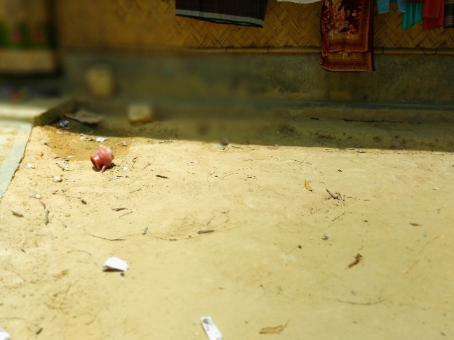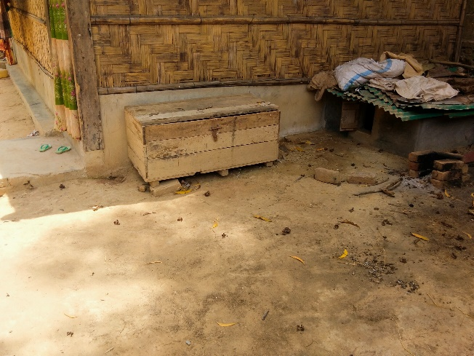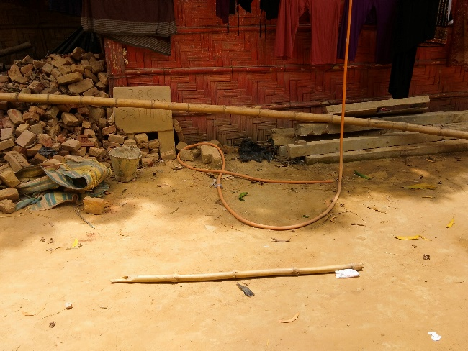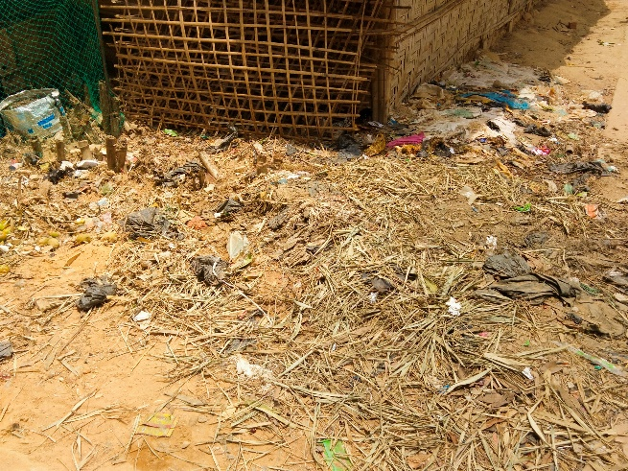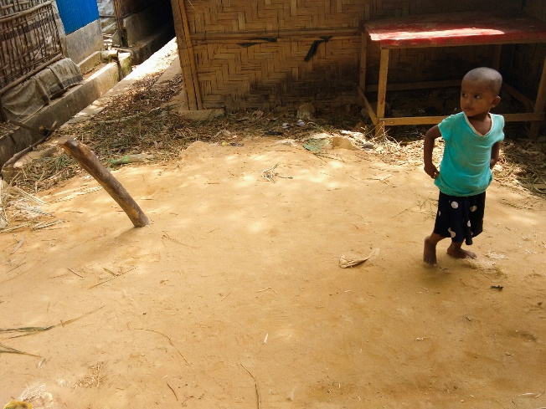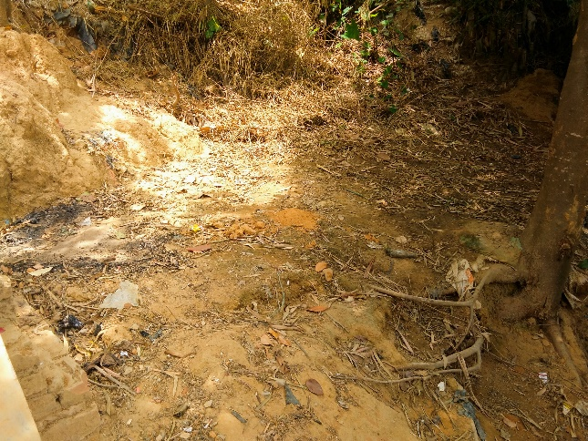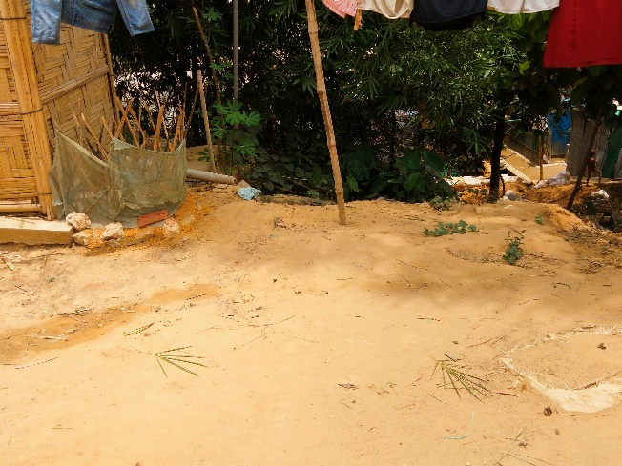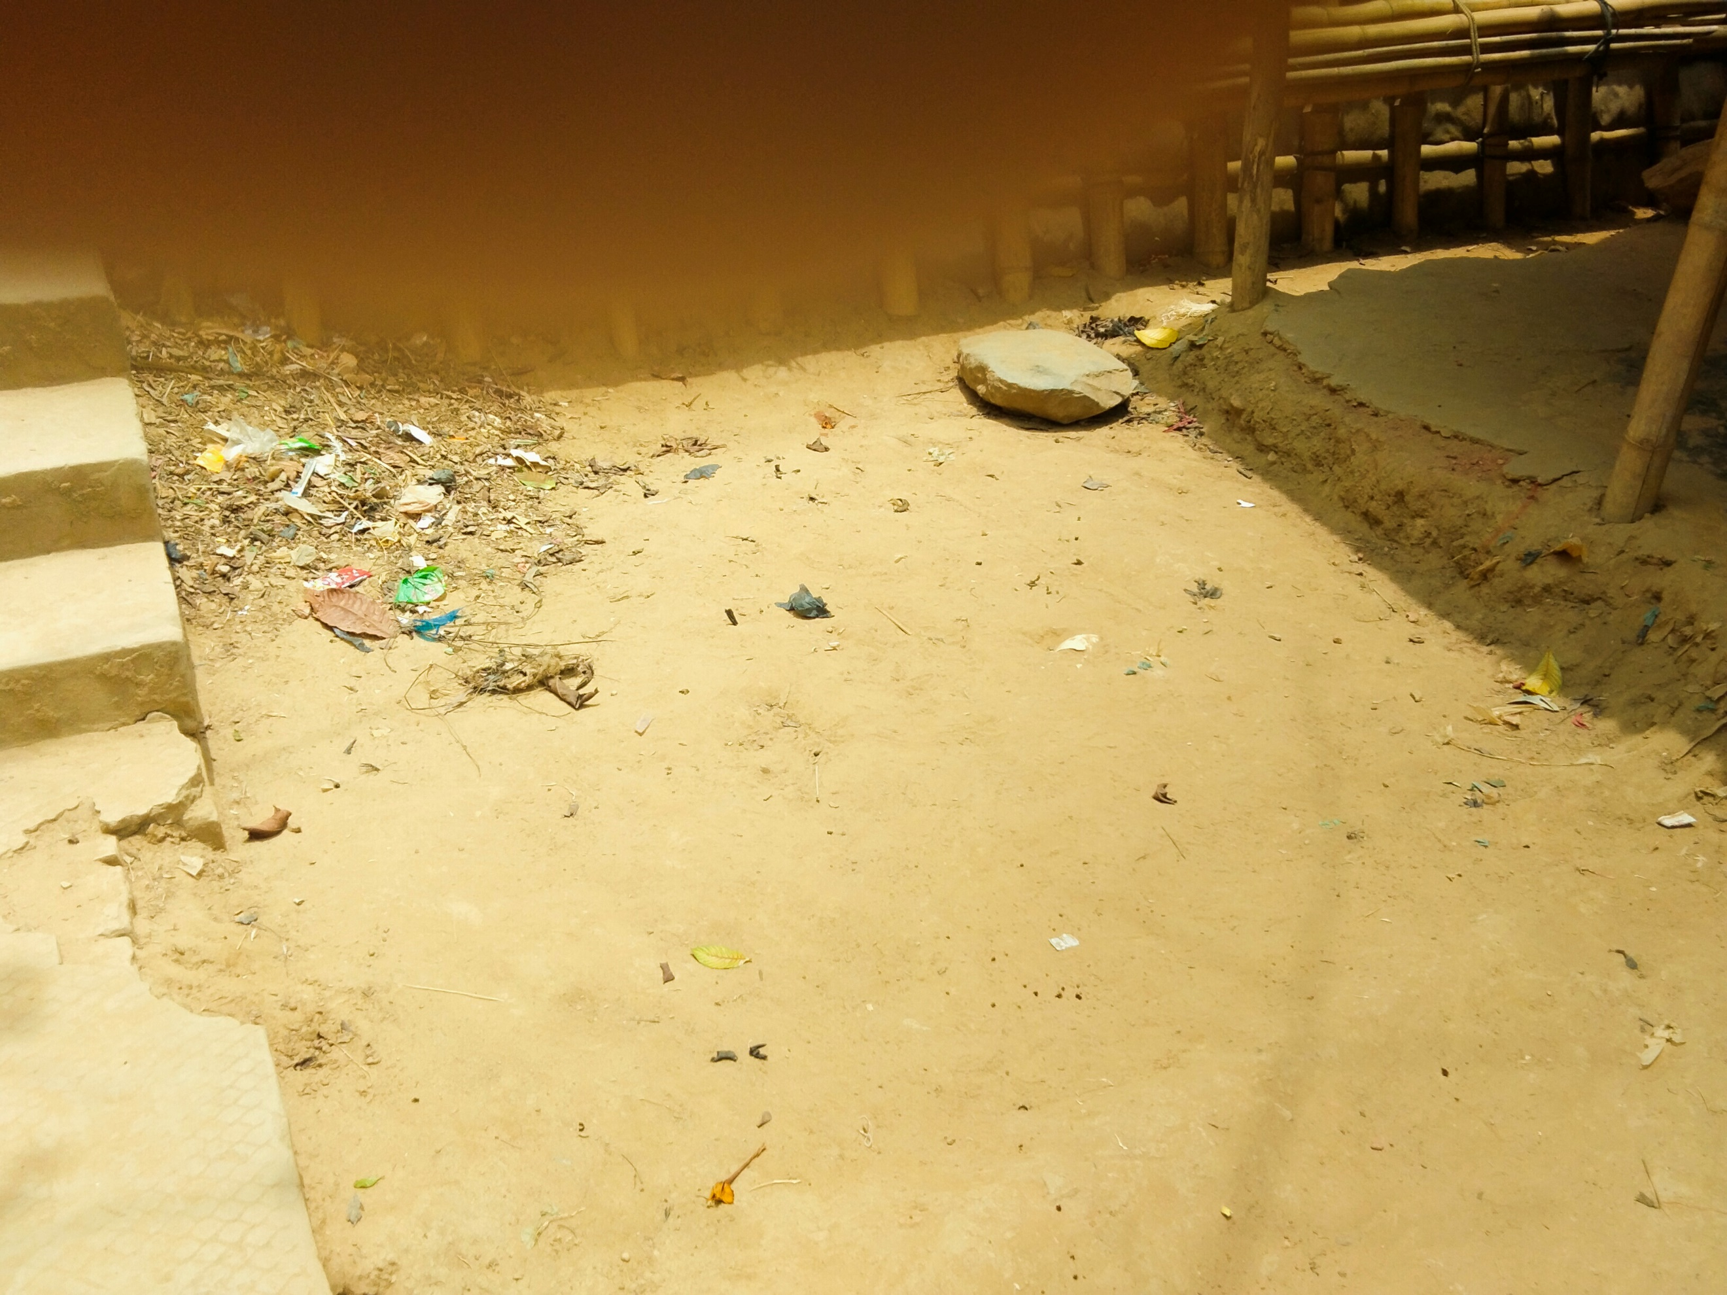

**Figure_1: Proposed household toilets Locations at Camp-17**

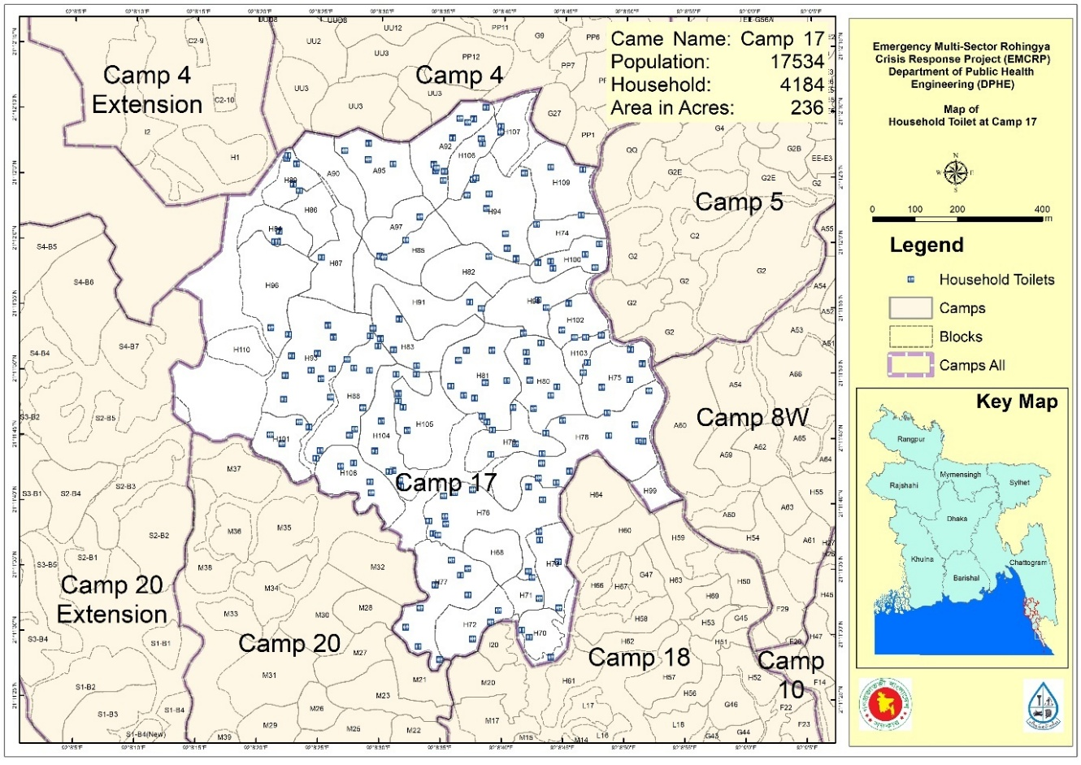

**Map_1: Location of proposed subproject sites at Camp-17 on base map of camp**

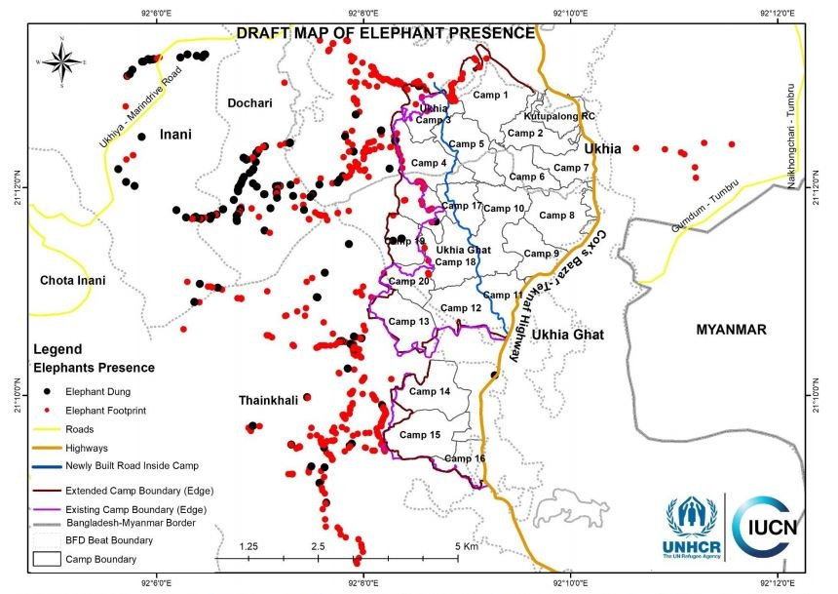

 **Map_3: Draft Map of Elephant Migration Road/ Presence around the Rohingya Camps**

# Environmental and Social Screening Form

## Section A: Subproject Overview

**Work Package:** WD-AF-29, **Construction of household toilet (Camp-17,** Block- A, B and C**)**

|  |
| --- |
| **Description of sub-project/component interventions:**  In the sub-project area, there is no adequate proper sanitation facilities to existing toilets. Hence, subproject areas community especially at Camp-17_ Block- A, B and C have been suffering for long time for lacking of proper sanitation. In addition, existing improper sanitation facilities degreed the quality of surrounding environment as well due to overloaded stress and less maintenance scope. In this context, DPHE has decided to meet up the necessity of subproject site people by constructing the household toilet under package EMCRP/ DPHE/ WD-AF-29, Camp-17. with ensuring following accessibility:  i). Construction of household toilet with ring pit & long pan (with foot raise)  ii) Supply of water bucket, water pot, brush with long handle (for cleaning)  iii) Post Commissioning Operation & Maintenance work: like-changing of damaged lock, cleaning of containment chamber, etc. |
| **Sub-project Location:**  Camp based household toilet is located at Camp-17, Block- A, B and C at Palongkhali Union under Ukhiya Upazila of Cox’s Bazar District. The proposed site is site at medium high land with bit slopping. Herringbone bond road very close to the household toilet sites. |
| **Land ownership:** Lands are solely owned by Government. |
| **Expected construction period:** 12 (twelve) months. |
| **Description of project intervention area and project influence area with schematic diagram *(where relevant, indicate distance to sensitive environmental areas such as elephant corridors, water bodies, etc. and historical or socio-cultural assets):***  The proposed lands for household toilets construction are vacant currently with covering of natural grown vegetation and few shrubs and herbs. This natural grown vegetation may be disturbed by the site clearing work. The land to be required for constructing of each household toilet is approximately 12 square meters. Around the subproject intervention areas covers mainly DRP settlement, recreation centers (like mosque, Madrasha, hebzokhana, etc.), HBB road, drain, vacant land, shops, etc. There is no environmental sensitive location (i.e., protected area, reserve forest, etc.) within sub project influence area. Elephant migration route is not within the camp, confirmed by the IUCN. There are some surface water bodies nearby some sites and within influence area few low land and natural channels are also available confirmed by the consultation of local people. There are manmade drains beside some proposed lands of household toilets & all drains are connected with natural cannels. During site visit, no archeological or historical site is recorded within influence area. |

## Section B: Environmental Screening

### B.1: Environmental feature of household toilet location

|  |
| --- |
| **Description of cultural properties *(if applicable, including distance from site):***  Within the household toilets areas (Camp-17) 1 CiC office, 1 community Center, 1 Disability specialized, 1 E-Voucher Outlet, 1 Helipad, 1 Site Operation Store, 2 Distribution Point, 2 General Food Distribution Point, 2 MHPSS Center, 2 Waer house, 3 Child Friendly Space, 92 learning centers, 4 Heath Post, 2 Feedback and Information Center, 1 Integrated Nutrition Facility, 3 Multi- purpose Protection Center, 1 Primary Health Center, 1 Skills Development Center,8 Cross Sectoral Shared Learning Center, 4 Safe Space for Woman and Girls, 2 Multi- Purpose Women Center, 4 Madrasah, 7 Hafez khana, 28 Moktab, 38 Mosque and 1 graveyards etc. are identified. No other sensitive cultural, archaeological or religious sites is there in the area. |
| **Location of environmentally important and sensitive areas:**  This location used to be environmentally important and sensitive as protected forest but now there is no forest at all. Erosion/land slide may occur when moderately to highly sloping terrains are disturbed for the construction of household toilet. But precast (will brought from outside of the camp) toilet parts like ring pit, pit top cover, top slab of toilet with long pan, etc. will be used for household toilet construction. The impacts are negative but very small scale, site-specific within a relatively small area and adjustable by mitigation measures.  **(1) Within/near Elephant Migration Routes Yes/No*: No**  **(2) Potential impacts on remaining forests in/around camps Yes/No*: No** |
| **Dust:** Ambient air quality data was not readily available. In the proposed site the existing air quality is almost dust free except for few months in the dry season (November to March).  **Noise:** Noise in the sub-project area is not a major concern based on the consultations. Noise is originating from communication among the DRP, service providers and relief distributors. |
| **Baseline soil quality:**  Soil types are alluvial reddish brown, muddy & sandy soil and dupitila formation. The soils developing from the weathered sandstones tend to be sandy to clay loams. Presence of organic matter content in the soil is moderate.  **Landslide potential *(high/medium/low, with explanation):***  **Low:** Potential erosion/land slide may occur when moderately to highly sloping terrains are disturbed for the construction of household toilet. But for household toilet this impact is low because maximum earth cutting depth is 1.8 m and this impact is very much site-specific, within a relatively small area and possible to easily mitigate by mitigation measures. |
| **Baseline surface water and groundwater quality *(FE, TDS, fecal coliform, pH):***  **Surface water quality:** This camp is located in the Government of Bangladesh owned hilly forest area where there is no pond water source but there is a river namely Reju Khal and its estuaries crossed many areas of the hilly forest areas of Ukhiya Upazila. Some data of surface water quality was found from the secondary source as follows: The surface water temperature ranged between 16°C in winter and 28°C in winter to pre-monsoon; the water pH varied from 7-8; the range of the salinity varied between 8 PSU in monsoon and 29 PSU in winter; dissolved oxygen ranged between 3mg/L (both in winter and monsoon) in monsoon and 4 mg/L in pre-monsoon. Total dissolved solids (TDS) ranged between 33 mg/L in monsoon and 35 mg/L in pre-monsoon. (Data source: Water Conservation and Management· August 2018).  **Groundwater quality:** Groundwater is the main source of potable water in the Sub-project area. The shallow depth is about 120 feet and deep tube well depth is 500ft to 750ft. In the sub-project area, groundwater is saline and arsenic free. Shallow tube well of surrounding the sub-project area are iron concentration is little high. pH7.5 to 8.50, DO2.20 to 8.50mg/l, TDS25.50 to 320 mg/l, EC 25 to 450 µs/cm, Fe0.50 to1.5 mg/l, Mn0.01 to 0.08 mg/l, Chloride12 to 65 mg/l and Nil to 0.001 mg/l. (Tube well depth: 500 ft. to 750 ft.). Many shallow tube wells have been installed in the camp area. This has resulted in excessive withdrawals of water from the shallow aquifer and a drying up of some of the wells.  *\*****Data source: Secondary data and field survey*** |
| **Status of wildlife movement:** None |
| **State of forestation:**  To accommodate large numbers of DRP, the hills were cleared and forest cut indiscriminately, and shelters have been set up on the hills. Steps have been cut into the slope to facilitate access to the shelters. Hill cutting loosens the soil and can result in soil erosion, sedimentation and siltation. Washing out of the valuable fertile top soil that will make the hills unsuitable for supporting any valuable vegetation cover. The eroded soil will also cause stream congestion, which might hinder stream flow, which in turn will result in habitat loss, water pollution and water scarcity. New plantations have been made by different organizations. |
| **Summary of water balance analysis *(For water supply scheme only):***  N/A |

### B.2: Pre construction Phase

|  |
| --- |
| **Information on Ancillary Facilities *(e.g., status of access road or any other facility required for sub-project to be viable):***  Regarding ancillary facilities at the concerned household toilet scheme area under this sub-project the main camp connecting herringbone road is very close to the sub-project area. However, the site is accessible and existing herringbone road is the most suitable way of carrying the construction materials (pipes, rig pits, pit top cover, toilet slab with long pan, cement, bricks, steel frame, tin, Steel Color Coated Industrial Roofing Sheet, sanitary materials, etc.) to the construction site. |
| **Requirement of accommodation or service amenities *(toilet, water supply, electricity)* to support the work force during construction:**  Toilet and water supply available but no electricity supply system in the sub-project area. If there are women labor proper lighting facilities should arrange, by using solar light, charger light etc. |
| **Possible location of labor camps:** Within the scheme area and very close to the sub-project sites. |
| **Requirement and type of raw materials *(e.g., sand, stone, wood, etc.):***  i) Bricks, ii) Sand iii) Cement iv) uPVC pipe vi) Gravel vii) Tiles viii) Sanitary materials ix) Water x) Iron flat bar xii) Roofing Sheet, xiii) reinforcement etc. are the most common type materials used in construction. |
| **Identification of access road for transportation (Yes/No): Yes.** This selected site is close to the Herringbone bond road. |
| **Location identification for raw material storage:**  Material storage stockyard is located outside of camp, but the area is within 1 km from the starting point of camp. |
| **Type and quantity of waste generated *(e.g., Solids wastes, liquid wastes, etc.)*:** None. |
| **Approx. area *(in square meters)* of vegetation and soil in the right-of-way, borrow pits, waste dumps, and equipment yards:**  No valuable vegetation presence in proposed sub-project construction sites (approx. 12 square meter land per household toilet). |
| **Possibility of stagnant water bodies in borrow pits, quarries, etc., encouraging for mosquito breeding and other disease vectors:**  ***(High/Medium/Low with explanation):***  None |
| **Disturbance or modification of existing drainage channels (rivers, canals) or surface water bodies *(wetlands, marshes):***  *(****High/Medium/Low with description):***  **Low:** Within 50 feet, there are manmade or natural drains. But during pre-construction phase impact is very low if construction materials will not store over the drain. |
| **Destruction or damage of terrestrial or aquatic ecosystems or endangered species directly or by induced development:**  ***(High/Medium/Low with description):***  **Low.** Under this scheme establishment interventions, the effect of destruction or damage of endangered species is negligible. |
| **Activities that can lead to landslides, slumps, slips and other mass movements in road cuts:** No |
| **Describe possible traffic movement impacts on *(unwanted)* light, noise and air pollution:**  Because of construction materials transportation noise & air pollution may occur. But this impact is very low because during pre-construction stage construction materials transportation is very minimal. |

|  |
| --- |
| ***High = Likely to cause long-term impacts or over large area (>1sqkm); Medium = Likely to cause temporary damage or over moderate area (0.5 to 1sqkm); Low = Likely to cause little, short-term damage and over small area (<0.5sqkm)*** |

### B.3: Construction Phase

|  |
| --- |
| **Type and quantity of waste generated *(e.g., Solids wastes, liquid wastes, etc.):***  **Solid waste:** i) Bricks, ii) Sand iii) uPVC pipes vi) Bamboo & wood and v) earth or mud vi) Sanitary materials vii) Iron flat bar viii) Steel Color Coated Industrial Roofing Sheet etc. It is difficult to give exact figures of construction waste produced on a household toilet construction site. However, 12 kg of waste may be produced per household toilet because precast parts like ring pit, pit top& bottom slab, etc. will be used. Excavated mud will be reused for backfilling also.  **Liquid waste:** Very small quantity of the solid waste will be generated during construction phase. On the other hand, operation of household toilets will generate fecal sludge and liquid waste i.e., Urine. |
| **Type and quantity of raw materials used *(wood, bricks, cement, water, etc.):***  i) Bricks, ii) Sand iii) Cement iv) uPVC pipe, v) Gravel vi) reinforcement vii) Sanitary materials incl. water bucket, water pot (bodna, mug), viii) Iron flat bar ix) Steel Color Coated Industrial Roofing Sheet etc. The exact quantity of raw materials to be used for each toilet is shown in the BoQ (Bill of Quantities) of the Cont. Pkg. WD-AF-29 Construction of H/H Toilets. |
| **Approx. area *(in square meters)* of vegetation and soil in the right-of-way, borrow pits, waste dumps, and equipment yards:**  No valuable vegetation presence in proposed sub-project construction sites. So, vegetation will not be affected by construction work. |
| **Possibility of stagnant water bodies in borrow pits, quarries, etc., encouraging for mosquito breeding and other disease vectors:**  *(****High/Medium/Low with description****)*  **Medium.** Earth excavation will be required for pit placement. Water stagnant may occurs if the place keeps open for long time after earth excavation. |
| **Disturbance or modification of existing drainage channels (rivers, canals) or surface water bodies (wetlands, marshes): *(High/Medium/Low with description)***  **Low.** Within 50 feet, there are manmade or natural drains. But precast materials (ring pit, toilet top slab with long pan, pit top cover, etc.) will be used. Some brick work & only four columns will be constructed at site and this impact is very much site specific & time specific. |
| **Destruction or damage of terrestrial or aquatic ecosystems or endangered species directly or by induced development:**  ***(High/Medium/Low with description):***  **Low.** Within 50 feet, there are manmade or natural drains. Outfall of manmade drains are connected with different natural canal. Even most of the sites are located at high area. During construction rain water may wash construction materials & can fall within natural water bodies. But precast materials (ring pit, top & bottom slab of pit, etc.) will be used. Some brick work & only four columns will be constructed at site and this impact is very much site specific & time specific. Waste from labor camp may fall into nearby drain & through the drain those wastes can fall into canal water). However, it would be minimal because contractor will dispose the generated waste into designated waste dump site regularly. |
| **Activities that can lead to landslides, slumps, slips and other mass movements in road cuts:**  None. |
| **Erosion of lands: (High/Medium/Low with description):**  **Low.** Potential erosion/land slide may occur when moderately to highly sloping terrains are disturbed for the construction of household toilet. But for household toilet this impact is low because maximum earth cutting depth is 1.8 m and this impact is very much site-specific, within a relatively small area and possible to easily mitigate by mitigation measures |
| **Describe possible traffic movement impacts on (unwanted) light, noise and air pollution:**  No traffic movement impacts on light as all vehicular movement will be during day time. Some temporary, localized effects of noise and air pollution can occur due to truck movements. |

|  |
| --- |
| ***High = Likely to cause long-term impacts or over large area (>1sqkm); Medium = Likely to cause temporary damage or over moderate area (0.5 to 1sqkm); Low = Likely to cause little, short-term damage and over small area (<0.5sqkm)*** |

### B.4: Operation Phase

|  |
| --- |
| **Activities leading to health hazards:**  In Operation phase of household toilet schemes, improper use of personal protective equipment (PPE) and lack of safety procedures may cause injuries. |
| **Chance of long-term or semi-permanent destruction of soils: *(High/Medium/Low with description)***  **Low.** Low change of long-term or semi-permanent destruction of soils for household toilet schemes area. |
| **Possibility of odor and water, soil quality impacts from SWM and FSM disposal system: *(High/Medium/Low with description):***  **Medium.** Sludge from household toilets will be generated. The sludge will be disposed properly in camp waste management facilities. Sludge will be collected by using vacuum truck with 50m suction pipe. Vacuam truck with 50 m sucktion pipe will be used. It hope that, it will be possible to collect fecal sludge from maximum household toilets using vacuam truck. In some cases if manual pit emptying is requred then proper pit emptying guidelines will be followed. Labours should use proper PPEs like hand gloves, safety boots, face masks, eye protecting glasses, etc. Since pits of household toilets are smaller in size, it will be easier to clean |
| **Possibility of stagnant water bodies in borrow pits, quarries, etc., encouraging for mosquito breeding and other disease vectors:**  ***(High/Medium/Low with explanation):***  None. |
| **Likely direct and indirect impacts on economic development in the project areas by the sub-project:**  Household toilet will be helpful of the DRP and improve their health condition. |
| **Extent of disturbance or modification of existing drainage channels (rivers, canals) or surface water bodies *(wetlands, marshes):***  ***(High/Medium/Low with description):***  **Low.** Within 50 feet, there are manmade or natural drains. Outfall of manmade drains are connected with different natural canal. This water body can be contaminated if generated waste from containment well or sock well get contact with road side drain water by runoff of precipitation. It will be possible because of containment well or sock well leakage or improper disposal of generated sewage waste from household toilets. But this chance is minimal. This impact is very much site specific & with proper management it is possible to mitigate. |
| **Extent of destruction or damage of terrestrial or aquatic ecosystem so endangered species directly or by induced development:**  ***(High/Medium/Low with description):***  **Low**. Operation and maintenance activities of household toilet schemes will be localized and temporary in nature. |
| **Activities leading to landslides, slumps, slips and other mass movements inroad cuts:**  N/A |
| **Erosion of lands:**  **None** |
| **Describe possible traffic movement impacts on (unwanted) light, noise and air pollution:**  Temporary, localized impacts on noise and air pollution from maintenance vehicles movement can occur during household toilet maintenance work. All maintenance works will be conducted during daytime – so no light impacts expected. |

|  |
| --- |
| ***High = Likely to cause long-term impacts or over large area (>1sqkm); Medium = Likely to cause temporary damage or over moderate area (0.5 to 1sqkm); Low = Likely to cause little, short-term damage and over small area (<0.5sqkm)*** |

**Section C: Social Screening**

## C.1 General Labor Influx Screening

|  |  |
| --- | --- |
| **Key Screening questions** | **Aspects to Consider** |
| **Will the project potentially involve an influx of workers to the project location, and will the influx be considered significant for the local community?** | The number of total skilled meson is 1 and unskilled labor 2 per household toilet. All the unskilled labor will be engaged from the DRP community. No foreign labor will be engaged. All the skilled labor will be staying at labor shed within the camp. The size of the labor shed (If there is women labor need to have separate shed and toilet) will be 225 square feet. |
| **Is the project located in a rural or remote area?** | The project area is in a camp area demarcated by the Government and belongs to Camp-17 in a remote specialized area. The total camp population is 19,058. The frequency and extent of the contract, communication between the local community and outsiders are limited, and controlled by the respective authority. After establishing the proposed per household toilet schemes in the area about 20 peoples will be benefitted to meet their water requirements. |
| **Based on the socioeconomic, cultural, religious and demographic qualities of the local community, Rohingya population and the incoming workers, is there a possibility that their presence or interaction with the local community could create adverse impacts?** | No. It is not expected that the presence of the skilled (local) and unskilled labor (DRP) may generate any adverse impacts. The project will benefit the DRP communities. There will be a code of conduct for the labors to follow, which will be monitored by the PMU on a regular basis. Before starting construction, work consultation will be conducted with construction labors & they will be given orientation on GBV issue. GBV, trafficking, child labor issue, labor influx, etc. will be monitored & monitoring progress will be incorporated within monthly progress report. |
| **Consultation with DRP Community People and relevant stakeholders (SH)** | During screening and site identification DPHE has conducted 2 (two) consultation meetings DRP community & with primary and secondary stakeholders. The stakeholders include CiC, WASH Sector, Site Management Committee representatives, Contractor team and DRP Community. In addition to the above-mentioned meetings, the local DPHE has undertaken many consultations with male and female members of the DRP.  Through the coordination and linkage activities of the project, the authorities have accomplished some formal exchange meetings, individual household visits, FGD, Tea Stall discussion and other consultation meetings. |

**C.2 Land acquisition and stakeholder screening**

|  |  |  |  |  |
| --- | --- | --- | --- | --- |
| **Probable Involuntary Resettlement Effects** | **Yes** | **No** | **Not Known** | **Remarks** |
| **Involuntary Acquisition of Land/ Land Donation/ Land Taking** | | | | |
| 1. **Will there be any land acquisition?** |  | √ |  | Land acquisition is not needed. |
| 1. **Is the project construction site known?** | √ |  |  | The land is selected based on needs of DRP community with the recommendation of CIC SMC & Local DPHE and assigned UN agencies |
| 1. **Who manages the land?** | √ |  |  | The lands are solely owned by the GOB and currently vacant. |
| 1. **Will easement be utilized within an existing Right of Way (ROW)/land? CRP (Common Resource Property)** | √ |  |  | In the camp area Provision is available be utilized within lands within this Camp-17 area under EMCRP. |
| 1. **Will there be loss of DRP tent, agricultural carps, trees, and other productive or fixed assets due to project intervention?** |  | √ |  | No DRP shelters will be affected. However, during construction if any shelters require to shift, mitigation measures will be taken according to RPF. Consultations will be conducted with stakeholders, camp and block focal persons, and site management. During construction, if any shelters are affected, contractors are responsible to mitigate the impacts following the RPF as well. |
| 1. **Will there be loss of businesses or enterprises due to project intervention?** |  | √ |  | No |
| 1. **Will there be loss of income sources and means of livelihoods due to project intervention?** |  | √ |  | No |
| **Involuntary restrictions on land use or on access to legally designated parks and protected areas** | | | | |
| 1. **Will people lose access to natural resources, communal facilities and services?** |  | √ |  | No |
| **Information on Displaced Persons:** | | | | |
| 1. **Any estimate of the likely number of persons that will be displaced by the Project?** [√ ] No [ ] Yes   **If yes, approximately how many?** | | | | |
| 1. **Are any of them poor, female-heads of households, or vulnerable to poverty risks?** [√] No [ ] Yes | | | | |
| 1. **Are any displaced persons from indigenous or ethnic minority groups?** [√ ] No [ ] Yes | | | | |
| 1. **Who are the stakeholders of the project? Please provide a summary of consultation meetings with stakeholders and the affected community.**   The key stakeholders of this sub-projects are DRP, Labors, People/communities/organizations within the project influence area indirectly affected by project activities, relevant government departments/agencies, Dept. of Environment and Forest Department, Development Partners (WASH Cluster, UNHCR, IOM, OXFAM) and Local and international NGOs working with local host communities/DRP.  For determining the environmental and social impacts associated with subproject implementation, DPHE, PMU unit give great importance on involving primary and secondary stakeholders of the subproject area. Therefore, to collect local knowledge for baseline conditions, understand perceptions of the community regarding impact significance, and propose meaningful mitigation measures during survey of Environmental Screening, an attempt has been made to consult with relevant stakeholders and DPHE officials to obtain their views on subproject interventions.  The Community consultation was conducted through a mix of conventional approach which involved as participatory, community consultations (FGD) and one-to one interviews, during the environmental and social study of the proposed subproject in conformity with the WB’s environmental guidelines. However, for better understanding the socio-economic and environmental condition 2 consultations with DRP community have been conducted in the subproject study area ***(Appendix-2).*** During site selection DPHE has also consulted with surrounded DRPs.  The community consultations were conducted with the following objectives: (i) to intrude awareness of the stakeholders about the subproject and to collect their opinion, suggestions for planning and designing of the subproject (ii) to identify the need and concern of the DRP public, (iii) to assess cultural patterns and behavior of local communities. Stakeholder consultation, was targeted at people/communities who may – directly or indirectly, positively or negatively- be affected by the outcomes of a subproject. The consultations were conducted at two different tiers of stakeholders: DRP people and different organization representative who are concern about the subproject. All of the proceedings and interaction of consultation and FGD have been recorded and are to be considered in the design of ESMF. In addition, attended list of participants of consultation meeting recorded and it’s been attached in ***Appendix-3*.**  **Feedback, Suggestions, and Recommendations of the Participants FGD**  The participants’ feedback, suggestions, and recommendations listed below:   * During consultation ESS team request them to keep household toilets clean during operation phase & they (DRPs) have assured that they will try to keep household toilets clean during operation phase. * They requested for regular maintenance of household toilets. Participants showed highly anxious about its operation and maintenance. In this regard, they suggested confirming who will take responsibilities for operation and maintenance. * They also expressed their concern about employment opportunities. They said that, if possible, non-skilled worker should engage from DRP community so that they can manage their livelihood. DPHE response that, unskilled labor for the construction work will be involve from DRP community. * They wanted provision of child and aged/ disable friendly toilets so that they can reach it easily. After construction of household toilets these problems will be solved. DPHE response that, during design that point was considered & proper stapes is also considered during design. * During construction work they also request to maintain proper safety measures. Since household toilets will be placed within household area, so excavated portion should not keep open for long time. After earth excavation contractor should place rings as quickly as possible. * Most of the participants expressed that the number of toilets that have been selected for at Camp_16 is not adequate. Most of the participants expressed that the number of toilets that have been selected for at Camp_16 is not adequate. DPHE response that, under the EMCRP (AF) project DPHE will be constructed 1000 bio-fil toilets, 3000 HH toilets. After implementation of the EMCRP this problem will be reduced. Earlier in the same project (SD-14) DPHE has also constructed 500 Bio-fil, 3000 HH toilets, 70 community toilets & 30 community toilets with biogas plant.   Individual level consultation with project interest and influence parties (CiC, Camp Wash focal team, UNHCR) representative were conducted in consistence with consultation objective during subproject selection stage to have their idea, concern, segregation about the proposed subproject. Consultation outcome with them is consolidated here in below:  **Responds of CiC/Site Management**   * Always try to coordinate with related authority/group and give updates to CiC; * CiC is ready to support DPHE, if they face any obstacle to implement the scheme; * After confirmation of site for schemes with the assistance of CiC and other related organization, site should be confined to avoid the neighboring disturbance * After site section then try to keep boundary of the scheme areas and hang a signboard as soon as possible including name of executing agency, types of intervention, address of contractor, project duration, funding agency name and so on. * Engage the DRP/Local community to implement the sub-project   **Wash Focal:**   * As the camp area is hilly land sometimes site/land needs to be developed to increase activities sustainability, * Ample temporary bin for waste collection during scheme implementation should arrange and regular disposal also need to be assured; * Intervention sites not to be allowed in the bank of natural water body except ensuring adequate mitigation; * Construction wastes that to be generated should be disposed regularly at designated sites.   Response of DPHE: DPHE response that, all suggestion provided by the wash focal will be considered during construction & operation maintenance phase of the project.  **UNHCR:**   * Intervention sites should not be located in the elephant migration corridor. Hence, elephant migration road map set by the IUCN/UNCHR should follow during site selection. * They requested to inform them, if project face any elephant incident during implementation   **RRRC:**  For development work of this subproject anywhere in camp area, project proponent needs to be taken approval from RRRC with the recommendation of camp-based concern authority along with the cooperation of local DPHE officials. DPHE response that, before starting the construction work DPHE will take clearance from the relevant authority. | | | | |
| 1. **What social and cultural factors affect the ability of stakeholders to participate or benefit from the proposed policy or project?**   None. | | | | |
| 1. **Are project objectives consistent with their needs, interests and capacity?**   Yes, the EMCRP project objectives consistent with the respective stakeholders, DRP and host community, needs, interests and capacity in the project areas. | | | | |
| 1. **What will be the impact of the project or sub-project on the various stakeholders, especially women and vulnerable groups?**   **Positive Impact:**  Women and girls continue to suffer suspiciously from inadequate sanitation, and often cannot use a toilet when and where they need because of inadequacy of household toilets in camps area. Therefore, after construction of households’ toilets in camps area, will assure safety net for women and disabled person by confirming easy access into nearby household toilets with minimum risk of sexual violence, harassment and physical violence since they are not to be forced to defecate in the open or use unsafe, dark or badly located toilets. Besides, user of households’ toilet usually less than household toilet, thereby keeping hygiene condition would be easier for the camp’s people. Camp-17, human waste (feces) will manage well by reducing contact of pollutants in the nearby water body, and soil. Resulting diarrhea and other health problem that are usually in connection with unhygienic sanitation system will mitigate by the well-designed household toilets. Around 20 people shall be benefited from one household toilet.  **Negative Impact:**  There will have no significant negative impact to the DRPs as well as in surrounding environment for constructing the household toilet. In fact, impact in connection with civil work for household toilets are also be minimum and very much site specific. Nevertheless, less impact by the construction work, there will have some impact to the women during period of menstruation because that time use of water by the women for maintaining hygiene is required more than normal time but there is no provision of pipe water supply access in the toilets. | | | | |
| 1. **What social risks might affect project or sub-project success?**   As per the visit findings and consultation meeting with DRP community, other organizations and representatives of the scheme area, it has been revealed and perceived that the following social risks might be affected to accomplish the scheme interventions:  Since the skilled labor will be engaged from the host community and unskilled laborers will be engaged from the DRP, there may be some conflict between the two groups. To establish the scheme tasks, additional labor from outside such as technicians will be engaged. Thus, there may be risk of some social conflict. A complete Gender action plan has already been developed and approved, a full time Gender Consultant for this project has been assigned to oversee the GBV based issues for this subproject. The gender and GBV issues (i.e., human trafficking, eve teasing, etc.) are being addressed through mainstreaming activities. As a mitigation measure, the Social Safeguard team and grievance redress committee (GRC) has been following the respective GRM, is keeping abreast on GBV occurrences and will guide the community through consultation meetings and counseling. Given the sensitivities in the camps areas (social, cultural, religious, gender, disabilities, orphaned and vulnerable children, relationship with DRP and host community), if the site area will be used as the open play space for the DRP kids, it might hamper their movement and play time for the time being. Unexpected noise, dust pollution, waste materials due to scheme establishment activities, might affect general social, religious activity of the DRP community at site area. However, by adopting the project E&S safeguard and through community consultation, the CiC, community leader and local DPHE representatives may determine possible ways and options to overcome and mitigate the constraints and risks during the scheme implementation. | | | | |

### C.3. Social Capital Format

The objective is to list various types of social institutes/bodies working in the camp, intended project influence areas to enlist them for the possible inclusion in the management, and monitoring of the projects. List the name of social institutes/ bodies under the given categorization along with the following information. Use separate sheet for each category of social institute/body. The information can be collected through secondary sources such as RRC/UN agencies or different development organizations that are involved with the Rohingya crisis projects, etc.

| **Type of Social Institutes/bodies** | **Name of Institution** | **Contact Person and Address and phone number** | **Primary areas of Work** | **Coverage areas in the camp and communities** |
| --- | --- | --- | --- | --- |
| Government Organizations | RRRC,  DPHE,  DC  LGED, MoDR  DRP CIC | Mr. Muhammad Mizanur Rahman  RRRC Commissioner, CXB,  Email [rrccox@yahoo.com](mailto:rrccox@yahoo.com)  …………………………  Md. Ibne Mayaz Pramanik, DPHE,  Executive Engineer, Cox’s Bazar,  [mayaz,pramanik*@gmail.com*](mailto:eng.mostafiz@gmail.com)  …………………………………  Mohummad Salah Uddin  DC, Cox’s Bazar  [*dccoxsbazar@mopa.gov.bd*Mr](mailto:dccoxsbazar@mopa.gov.bdMr).  S.M. Ishtiaque Shahriar  Senior Assistant Secretary  Camp-in-Charge, Camp-17  camp17@rrrc.gov.bd | Overall Coordination of GOB dept., Dev. partners, NGO, INGIO, UN Agencies, Volunteers,  Management of DRP Crisis in BD. Refugee Relief and Repatriation, Site management,  Ensuring DRP HH shelter, F/NFIs, WASH facilities, Education, Health, Livelihoods, Social security, power sources, renewable solar energy. | DRP Camps, Blocks, synchronizing with Host, E&S aspects, Elephant corridors, conserve NR. Establish proper road communication. |
| UN Agencies /INGOs | WSC  IOM, UNICEF, WFP,  FAO , UNHCR  UNFPA | MD, Muntasirul Meher  WASH CFP, CARITAS,  camp-17  Abdul Mazed  WASH Associate,  UNHCR, Camp-17 | Management of DRP Crisis in BD. Refugee Relief and Repatriation, Site management,  Ensuring DRP HH shelter, F/NFIs, WASH facilities, Education, Health, Livelihoods, Social security, power sources, renewable solar energy. | DRP Camps, Blocks, synchronizing with Host, E&S aspects, Elephant corridors, conserve NR. Establish proper road communication. |
| National Organizations | Not yet on boarded | the database web link  <https://www.humanitarianresponse.info/en/operations/bangladesh/document/wash-sector-coxs-bazar-members-contact-list-17-october-2017> |  |  |
| Volunteer Organizations are those, which constitute the members of the community working towards social development. | Not yet involved | N\ A. Prohibited by the GoB. | Ensuring DRP HH shelter, F/NFIs , WASH facilities , Education , Health , Livelihoods , Social security , power sources , renewable solar energy . |  |

## Section D: Environmental and Social Screening Summary

### Environmental Screening Summary

Based on the above environmental and social screening, potential impact for implementing the proposed intervention on different parameters of environment and social with consequence mitigation measures and suggestive monitoring plan with mentioning the responsibilities parties of implementation and supervise the subproject project have been summarized in below.

| **Section** | **Main Environmental and**  **Social Impacts** | **Impact Significance** | **Suggested Mitigation Measures** | **Person/ Institution Responsible** | **Monitoring Suggestions** | |
| --- | --- | --- | --- | --- | --- | --- |
| **Indicators** | **Frequency** |
| **1: Sub-Project Interventions** | **Air Quality** | Under the subproject intervention the overall score is **low**. | * Limiting earthworks; * Watering of dry exposed surfaces and stockpiles of aggregates at least twice daily, as necessary; (spreading of crushed gravel over backfilled surfaces; * Work place isolated by fencing active work sites in populated areas. * Limiting speed of construction vehicles in access roads and work sites to maximum of 20 kph. * More details provided in ESMP | Construction Contractor monitored by Environmental Consultant and PMU | * Location of stockpiles; * Number of complaints from stakeholders; Covering of trucks; * Records of air quality inspection; | Regular visual monitoring will be required. |
| **Soil** | Under the sub-project intervention, the overall score is **low.** | * Precautions might be taken when rainstorms are likely, when a rainstorm is imminent or forecast, and actions to be taken during or after rainstorms shall be developed by the Contractor. * The earthwork sites where exposed land surface is vulnerable to runoff shall be consolidated and/or covered. * Channels, earth bunds, netting, tarpaulin and or sand bag barriers shall be used on site to manage surface water runoff and minimize erosion. * The overall slope of the works areas and construction yards shall be kept to a minimum to reduce the erosive potential of surface water flows elsewhere. * More details provided in ESMP | Construction Contractor monitored by Environmental Consultant and PMU | * No visible degradation to nearby drainages, * Canals or water bodies due to soil erosion. * Rain storms in construction phase. | Weekly, especially after rain events |
| **2: Pre-construction Phase** | **Impact on Existing drainage: drain may block, due to storage of construction materials on or next to the drain.** | Under the sub-project intervention, the overall score is **low** | * The Contractor will not be allowed to store construction materials beside drains * Regular monitoring is essential * If any materials fall within the drain, contractor will clean the drain immediately. | Contractor and monitored by Environmental Consultant and PMU | * List of materials and sources of materials; * Storage site away from the drain | Weekly |
| **Storage of construction materials can cause pollution or land slips** | Under the sub-project intervention, the overall score is **low.** | * Train the concerned person, team assigned for the construction work regarding proper storage procedures: away from steep slopes, proper bonding to avoid runoff from site. * More details provided in ESMP | Contractor and monitored by Environmental Consultant and PMU | * List of materials and sources of materials; * Storage site away from steep slopes and has proper bonding | Weekly |
| **Transportation impacts** | Under the sub-project intervention, the overall score is **low.** | * All vehicle movement to be done during the day time * Speed needs to be limited to 20kmph * Contractor’s responsibility to verify the suitability carrying, loading and unloading of materials by trucks or others transport and head load arrangement. * More details provided in ESMP | Construction Contractor and monitored by Environmental Consultant and PMU | * Check the vehicle pool. * Record of regular inspection. * Record of accidents/incidents | Monthly monitoring. |
| **3: Construction Phase** | **Construction Waste (excavated soil etc.)** | Under the sub-project intervention, the overall score is **Low.** | * Wastes must be placed in the designated bins which must be regularly emptied. * All waste must be removed from the site and transported to a disposal site. * More details provided in ESMP | Contractor and monitored by Environmental Consultant and PMU | * Complaints from community; * Regular inspection of waste management activity; * Waste disposal record. | As work weekly progresses |
| **Stagnant water risk** | **Medium** Earth excavation will be required for pit placement. Water stagnant may occurs if the place keeps open for long time after earth excavation. | * Water stagnant area should fence with marking tape * The top soils in the sub-project are sandy and the water should drain away quickly * Contractor should arranger proper water pumping facilities (pup, etc.) * Proper safety is essential during construction work. | Construction Contractor foreman and monitored by Consultant and PMU | * Water stagnant beside household toilet area | Daily during construction |
| **Storage of materials**  (Creating dust/ air pollution spillage of liquid/ hazardous substance i.e., oil, drilling fluid, chemicals etc., Risk of crime) | Under the sub-project intervention, the overall score is **Low.** | * By the site management committee in Camp to identify the storage site and other requirements, which will be approved by PMU and consultants. * More details provided in ESMP | Contractor and monitored by Environmental Consultant and PMU | * List of materials and sources of materials; | Monthly basis during implementation phase. |
| **Impact on Drain & Aquatic Environment** by discharging solid & liquid wastes from construction site & labor camp into nearby drain & through the drain those wastes can fall into canal water | Under the sub-project intervention, the overall score is **Low** | * Generated waste and construction debris shall be properly disposed in accordance with the approved designated disposal site(s); * Acceptable quality of excavated soil shall be mostly reused for the backfilling, with the surplus portion, if any, disposed in the approved designated disposal site(s). * Separate waste collection bins, for organic and inorganic wastes, shall be provided throughout the construction and camp sites, whereby all waste collection bins shall be regularly emptied and cleaned; * Contractor will be responsible to control the workers from discharging of construction waste into adjacent water bodies. | Contractor and monitored by Environmental Consultant and PMU | * Frequency of emptying the waste bin * Existence of waste bin | Monthly basis during implementation phase. |
| **Erosion of land** | Under the sub-project intervention, the overall score is **Low** | * During construction work (especially for earth excavation) proper slope protection is essential. * During backfilling work proper compaction is essential (as per specification) * Avoid earthwork during monsoon * Proper safety is essential during construction work. | Construction Contractor foreman and monitored by Consultant and PMU | * No visible degradation to nearby drainages or water bodies due to soil erosion at/near sub-project site. | Daily during earth excavation work & work below GL |
| **Noise pollution** | Under the subproject intervention the overall score is **Low** | * Consultation with affected people; not to operate noisy equipment during working and operations time (22:00 – 06:00); * Sound suppression for equipment; * Ear protection for workers. * Conduct noise quality monitoring as per ESMP. * Limiting speed of construction vehicles in access roads and work sites to maximum of 20 kph. * Transportation of the construction materials and noisy construction work have to be carried during the scheduled times, and mainly during the day | Construction Contractor and monitored by Consultant and PMU | * Number of complaints from stakeholders; Use of silencers in noise-producing equipment and sound barriers; * Noise Level following decibel meter (dB) | Inspection by PMU and supervision consultants on monthly basis; |
| **Air pollution** | Under the sub-project intervention, the overall score is **low.** | * Water spraying from other source for dust control; * Construction materials with potential for significant dust generation shall be covered; no smoke emitting equipment; and limiting speed of construction vehicles in access roads and work sites to maximum of 20 kph. * More details provided in ESMP | Construction Contractor and monitored by Environmental Consultant and PMU | * Location of stockpiles; * Number of complaints from stakeholders; * Records of air quality inspection; Air quality test report. | Regular visual monitoring will be required. |
| **4: Operational Phase** | **Health & Safety Hazard** | Site staff can be seriously hurt by accidents. **Low** | * Ensure proper training given to all operation team and users. * Ensure PPE used by all staff * Ensure use of vacuum tanker/pump to collect desludged material & dumping to proper dumping site. Vacuam truck with 50 m sucktion pipe will be used. It hope that, it will be possible to collect fecal sludge from maximum household toilets using vacuam truck. In some cases if manual pit emptying is requred then proper pit emptying guidelines will be followed. Labours should use proper PPEs like hand gloves, safety boots, face masks, eye protecting glasses, etc. Since pits of household toilets are smaller in size, it will be easier to clean. | Camp WASH, NGO staff and  Local DPHE | * Accidents register | During containment well cleaning work. |
| **Destruction of soil** | The operation period may be possible soil damage problems in the project areas by rainstorms and overall score is **low.** | * Safeguards to be taken at any time of year when rainstorms are likely, actions to be taken when a rainstorm is imminent or forecast, and actions to be taken during rain storms shall be developed by the Contractor. * More details provided in ESMP | Construction Contractor weekly monitored by Environmental Consultant and PMU | * No visible degradation to nearby drainages or water bodies due to soil damage at pipe laying area. | Site inspection weekly/2-weekly in rain season. |
| **Odor & waste disposal of sludge from household toilet** | Under the issue the overall score is **Medium.** | * Sludge will be collected by using vacuum truck with 50m suction pipe. Vacuam truck with 50 m sucktion pipe will be used. It hope that, it will be possible to collect fecal sludge from community latrine using vacuam truck. In some cases if manual pit emptying is requred then proper pit emptying guidelines will be followed. Labours should use proper PPEs like hand gloves, safety boots, face masks, eye protecting glasses, etc. * Ensure use of vacuum tanker/pump to collect desludged material & dumping to proper dumping site. Vacuam truck with 50 m sucktion pipe will be used. It hope that, it will be possible to collect fecal sludge from maximum household toilets using vacuam truck. In some cases if manual pit emptying is requred then proper pit emptying guidelines will be followed. Labours should use proper PPEs like hand gloves, safety boots, face masks, eye protecting glasses, etc. Since pits of household toilets are smaller in size, it will be easier to clean. * Appropriate awareness programs shall be arranged for the community members on health and hygiene issues and the impacts of improper sanitation practices; * Ensure disposal tanks, drums or containers coming to, and from, the site are in a satisfactory condition – check for damage or leaks; * Ventilation systems and facilities shall be kept in good functional in order to minimize untoward odor problems. | Construction Contractor up to defect liability period. Consultant and PMU  Long-term responsibility to be determined by CIC/DPHE | * Complaints from communities | Site inspection daily/weekly basis. |
| **Impact on existing drainage & Aquatic Environment** | Aquatic environment may pollute by discharging fecal sludge & liquid waste to the surface water. But impact is site & time specific so overall score is **low**. | * Ensure use of vacuum tanker/pump (if possible) to collect desludged material & dumping to proper dumping site * Appropriate awareness programs shall be arranged for the community members on health and hygiene issues and the impacts of improper sanitation practices; * Ensure disposal tanks, drums or containers coming to, and from, the site are in a satisfactory condition – check for damage or leaks; | Construction Contractor up to defect liability period. Consultant and PMU | * Survival rate of nearby aquatic animal; * Recorded any incident on aquatic animal * Recorded complaint if any | During containment well cleaning work. |
| **Noise pollution** | Under the subproject intervention the overall score is **Low** | * Limiting speed of maintanence vehicles in access roads and work sites to maximum of 20 kph. * Transportation of the fecal sludge & other liquid waste have to be carried during the scheduled times, and mainly during the day | Long-term responsibility to be determined by CiC/DPHE | * Noise from maintenance vehicle | During Maintenance work |
| **Air pollution** | Under the sub-project intervention, the overall score is **low.** | * Limiting speed of construction vehicles in access roads and work sites to maximum of 20 kph. * More details provided in ESMP | Construction Contractor up to defect liability period. Consultant and PMU | * Dust due to vehicular movement | During Maintenance vehicle movement |
| **5: Potential Natural Hazards** | **Cyclone** | Seasonal or weather depression and the overall score is **low to medium**. | * Measures to be taken (DRR) at any time of year when cyclones are likely to happen. * DPR People need to ensure the safety of valuable resources before increasing the signal. * The public should regularly listen to the latest special weather bulletins and public disaster warnings and take steps to take action in accordance with these regulations. * Organizations concerned with disaster management must be prepared. The disaster management committee at all levels should meet in a meeting and keep all preparations for possible response activities. | Construction Contractor, monitored by Environmental Consultant & PMU. Long-term responsibility to be determined by CiC/ DPHE/ PMU | * Weather Forecasting procedure/ Depression | Site inspection weekly and monthly basis. |
| **Flash Flooding** | May occur due to runoff from rainstorms and the overall score is **low**. | * Protection to be taken at any time of year when rainstorms are likely, actions to be taken when a rainstorm is imminent. * If there is a heavy rainfall in a higher area, it affects the lower areas. Therefore, if there is heavy rainfall in any high area, advance warning measures should be taken in the lower areas. * The embankment should be constructed considering the damage caused by flash floods. | Construction Contractor, monitored by Environmental Consultant & PMU. Long-term responsibility to be determined by CiC / DPHE/PMU | * Weather Forecasting procedure, Rainstorms | Site inspection weekly and monthly basis on rainy season or during heavy rainfall. |
| **Land sliding** | Land slide may occur due to runoff from rainstorms and the overall score is **low**. | * Protection to be taken at any time of year when rainstorms are likely, actions to be taken when a rainstorm is imminent or forecast, and actions to be taken during or after rainstorms. * Identification of vulnerable populations living in hilly areas. * Establish clear accountability in private ownership for relocation of vulnerable populations from mountains owned by private organizations or individuals. * Strengthen inter-departmental coordination in landslide early warning and early action. * Prohibition of human settlement and other social activities in hilly areas. * Planned intensive afforestation in hilly areas. | Construction Contractor for first 2 years monitored by Environmental Consultant. Long-term responsibility to be determined by CiC/DPHE | * Visible sliding prone Land (Hill or Tilla) area to nearby sites scheme area. | Site inspection and monthly basis on rainy season or during heavy rainfall. |
|  | **Fire** | The main cause of fire is carelessness. Ignorance goes hand in hand with carelessness.  The overall score is **low**. | * Remember that fire prevention is better than firefighting. Therefore, there should be a fire prevention system everywhere including homesteads, government-private offices-courts, mills-factories. * Turn off the stove after cooking. Avoid using open lamps. * Continue to extinguish the fire until the arrival of the fire service vehicles. * Old fittings should be checked at least once a month and replaced if necessary. * All equipment must be earthed. Experienced people should be employed in the handling of chemicals and fuels. * Establishments should have adequate fire extinguishers stocked and trained personnel. | Construction Contractor up to defect liability period. Consultant, CIC, DPHE and PMU | * Recorded any fire. * Recorded complaint if any | Regular visual monitoring will be required. |

|  |
| --- |
| ***\* Overall Impact Score: High = Likely to cause long-term E&S impacts; Medium = Likely to cause temporary impacts; Low = Likely to cause little, short-term impacts*** |

### Social Screening Summary:

To furnish the details of social screening, the ESMF has been followed focusing on major social impacts and significance of the sub-projects (Equity, labor influx, population coverage, easy access, GBV), impact mitigation measures, referral, monitoring suggestions. No land acquisition is required for this sub-project. Provision of utilizing existing lands is available for household toilet sites within this Camp-17. The sub-project location was selected with the support of RRRC, CIC, SMC and local DPHE. Consultation meeting was also conduct with local representatives who will be direct or indirectly related in the sub-project. The assigned consultants and local DPHE, CiC representatives, SMC and WASH focal team have visited the proposed site location and after then prepared the screening report. Initially the team surveyed the locality and primarily sorted (2-3) places to establish the scheme. It has been sorted out the exact situation on sanitation provision through consultation meeting with them. The foot of hill, natural drain or cannel, toilet and others environmental obstructions not close to the site.

#### Construction induced impact issues:

Since the household toilet sub-project interventions is being implemented in an empty place of Government-owned land and there is no land acquisition, so there will be arise any construction induced impacts. During construction, movements of heavy vehicles or construction materials may cause damages to the shelters or assets. If any damages are reported, DPHE will hold consultations with the site management along with contractors and camp focal points to take mitigation measures according to ESMF and RPF.

#### Labor issues:

Every household toilet establishment scheme will be executed by the contractor who will engage both skilled (1-2 nos.) & unskilled (2-3 nos.) labors. The unskilled labor will be engaged from the camp while the 1-2 skilled labor from the local/host community/other places of Bangladesh. No foreign labor will be required to implement the sub-project activities. Since the number of external workers will be very few and working for short periods of time (not more than 3 months), usually there will have no competition in using resources amongst the host and DRP communities. Thus, the sub-project will not create any influx of workers. The unskilled labors will be hired from the DRP community of Camp-17, who already reside in the camp. The skilled labors will be accommodated on site in the DRP camp by the contractors. The contractor will make temporary labor shed for both of his male & female (if necessary) labor. Area of the shed will be around (15ftX15ft) for males and (15ftX12ft) for females. All laborers (skilled and unskilled) shall be given appropriate training and capacity development to entail a multitude of codes of conduct pertaining to conflict, GBV and other issues.

#### Linkage with other stakeholders:

The team has provided emphasis to keep better linkage with related stakeholders (*i.e.* RRRC, CiC, Camp focal, WASH focal, DRP & Host Community, INGO & Local NGO *etc.*). The team conducts several types of consultation meeting with them group/individually for any social issues.

#### GBV issues:

The proposed sub-project activities will involve very minor civil works through skilled (from the host community) and unskilled (from the DRP community) labor. A strict labor code of conduct will be enforced. A GRM will be established to deal with related issues. The team will conduct consultation meetings with the DRP, contractors and labor to address GBV. If any odd situations arise, the GRC will attempt to mitigate any issues according to the ESMF GRM guideline. On the other hand, if any private land/land leases issues arise, the team will conduct a consultation meeting with the owner and relevant stakeholders according to the ESMF & resettlement guideline. GBV issues will be monitored & monitoring progress will be incorporated within monthly progress report.

Beyond of these, under the UNFPA 9th Country Programme ‘‘Advanced gender equality, women’s and girls’ empowerment, and reproductive rights, including for the most vulnerable and marginalized women, adolescents and youth’’ will be achieved as the project is a part of Gender Component of the UNFPA 9th Country Programme. In the event any issues on GBV arise, they will be well communicated with UNFPA through appropriate channels to resolve the issue following proper processes.

Various tools will be developed/adapted to facilitate GBV services, MHPSS services and engaging men and boys into GBV prevention work. Along with the GBV case management services, GBV and labor code of conduct awareness programs will be implemented, where all stakeholders including the host and DRP communities, labor engaged for the project, site management, the WB and project clients such as DPHE and LGD can participate.

#### Consultations and Future Consultations:

Under the EMCRP, the DPHE has initiated elaborate consultations with various stakeholders of this project for the household toilet Schemes site management. These include GIS specialist (initially), hydro geologist located in the scheme area, E&S consultants, local DPHE authorities, other development partners such as UN as well as the DRP community. These sessions covered topics such as WB introduced Social and Environmental safeguard issues, GRM, possible social environmental and economic effects, livelihoods options, discussions on minimizing the laborer conflict among DRP and local host communities, Infrastructure, WASH, hygiene, GBV, forestation, waste, sludge management. It was also determined that there is no Elephant corridor and no scope of Elephant/Human conflict in the site area. The DRP community were made aware and sensitized on E&S safeguard issues, precautions, child safety, avoid resettlement, relocations of local institutions (mosques, school/ learning centers & others, any restrictions for the DRP, and compensation mechanisms in the event of any objection and complaints.

As a result of these consultations, the community very much welcomed and appreciated the DPHE EMCRP initiatives on WASH sector sub projects. As per their opinion, the safe water and improved sanitation (Toilet Construction) is one of the priority needs for them for secured and better livelihoods.

Thus, future consultations during the lifetime of the project are expected to ensure that negative social and environmental impacts are being mitigated with due consideration of community needs and opinions. Consultations will involve determining with the site management team whether proper signage is being used (e.g. for occupational hazard) and whether a properly GRM system is being implemented through an efficient GRC. The GRM will be set up to serve as an integral tool for engaging the various stakeholders during the project activities and its implementation. There will have a complaint book for stakeholders where all sorts of complaint will be registered. The GRM will be institutionalized with qualified personnel having adequate training in deal with relevant complaints. The GRM will be available for a wide array of issues such as malpractice, labor issues and GBV.

#### Health and Safety Issues:

The Contractors must carry out a risk assessment and do what’s needed to be taken care of the health and safety of labors, employees and visitors. Incidents or accidents must be recorded and reported to the Bank through PMU, EMCRP within 24 hours. If any incident happen that should be informed to concerned authorities.

#### Labor and Contractors management during COVID-19:

**Recommendations For projects involving construction/civil works:**

Contractors will develop specific procedures or plans so that adequate precautions are in place to prevent or minimize an outbreak of COVID-19, but at present there is no outbreak of COVID-19 in the sub-project area. If COVID-19 or any others Diseases outbreak again what should be done if a worker gets sick.:

* DPHE has oriented the contractor and labor on Covid-19 management including OHS (Occupational Health Safety).
* Assessing the characteristics of the workforce, including those with underlying health issues or who may be otherwise at risk
* Confirming workers are fit for work, to include temperature testing and refusing entry to sick workers
* Considering ways to minimize entry/exit to site or the workplace, and limiting contact between workers and the community/general public
* Training workers on hygiene and other preventative measures, and implementing a communication strategy for regular updates on COVID-19 related issues and the status of affected workers
* Treatment of workers who are or should be self-isolating and/or are displaying symptoms
* Assessing risks to continuity of supplies of medicine, water, fuel, food and PPE, taking into account international, national and local supply chains
* Reduction, storage and disposal of medical waste
* Adjustments to work practices, to reduce the number of workers and increase social distancing
* Expanding health facilities on-site compared to usual levels, developing relationships with local health care facilities and organize for the treatment of sick workers
* Building worker accommodations further apart, or having one worker accommodation in a more isolated area, which may be easily converted to quarantine and treatment facilities, if needed
* Establishing a procedure to follow if a worker becomes sick (following WHO guidelines)
* Implementing a communication strategy with the community, community leaders and local government in relation to COVID-19 issues on the site.
* For supporting health facilities, plans or procedures will be in place to address the following issues:
* Obtaining adequate supplies of medical PPE, including gowns, aprons, curtains; medical masks and respirators (N95 or FFP2); gloves (medical, and heavy duty for cleaners); eye protection (goggles or face screens); hand washing soap and sanitizer; and effective cleaning equipment. Where relevant PPE cannot be obtained, the plan should consider viable alternatives, such as cloth masks, alcohol-based cleansers, hot water for cleaning and extra hand washing facilities, until such time as the supplies are available
* Training medical staff on the latest WHO advice and recommendations on the specifics of COVID-19
* Conducting enhanced cleaning arrangements, including thorough cleaning (using adequate disinfectant) of catering facilities/canteens/food/drink facilities, toilets/toilets/showers, common areas, including door handles, floors and all surfaces that are touched regularly
* Training and providing cleaning staff with adequate PPE when cleaning consultation rooms and facilities used to treat infected patients
* Implementing a communication strategy/plan to support regular communication, accessible updates and clear messaging to health workers, regarding the spread of COVID-19 in nearby locations, the latest facts and statistics, and applicable procedures.

**COVID Management Guidelines during implementation**

1. **Labor, Workers and Working Conditions:**

Contractors are responsible to manage the labors, workers and working conditions. PMU with the support of superstition and monitoring firms will ensure implementation.

* Stop any Project Activities that may increase community exposure to COVID risks
* Communicate to communities about protective COVID risks and measures
* Monitor incidence and outbreak of communicable diseases
* Identify hotspots based on health data available
* Screen Security personnel for COVID
* Follow strict protocols in management of project interventions that may increase the COVID risk for human health (for instance in livestock and commercial farming)
* Undertake preventive measures in resettlement settlements
* Practice social distancing in meetings, workshops and consultations

1. **Entry/Exit to the work site and checks on commencement of work:**

* Entry/exit to the work site will be controlled and documented for both workers and other parties, including support staff and suppliers. Possible measures will include:
* Controlling entry/exit to the site, securing the boundaries of the site, and establishing designating entry/exit points. Entry/exit to the site will be documented.
* Training security staff on the (enhanced) system that has been put in place for securing the site and controlling entry and exit, the behaviors required of them in enforcing such system and any COVID -19 specific considerations.
* Training staff who will be monitoring entry to the site, providing them with the resources they need to document entry of workers, conducting temperature checks and recording details of any worker that is denied entry.
* Confirming that workers are fit for work before they enter the site or start work. Special attention will be paid to workers with underlying health issues or who may be otherwise at risk. Consideration will be given to demobilization of staff with underlying health issues.
* Checking and recording temperatures of workers and other people entering the site or requiring self-reporting prior to or on entering the site.
* Providing daily briefings to workers prior to commencing work, focusing on COVID-19 specific considerations including cough etiquette, hand hygiene and distancing measures, using demonstrations and participatory methods.
* During the daily briefings, reminding workers to self-monitor for possible symptoms (fever, cough) and to report to their supervisor or the COVID-19 focal point if they have symptoms or are feeling unwell.
* Preventing a worker from an affected area or who has been in contact with an infected person from returning to the site for 14 days or (if that is not possible) isolating such worker for 14 days.
* Preventing a sick worker from entering the site, referring them to local health facilities if necessary or requiring them to isolate at home for 14 days.

1. **Land Acquisition and Involuntary Resettlement:**

Though this sub-project will not require land acquisition and involuntary resettlement but during implementation if any involuntary resettlement issues arise, following steps will be followed:

* Identify vulnerable PAPs and Non-title holders who may have increased vulnerability due to COVID outbreak and (lockdown or loss of livelihood); particularly NTH
* Make accelerated payments for compensation and/or livelihood restoration to project affected persons, especially vulnerable households, non-titled holders to help them cope with lockdown;
* Employ local population on wage labor, make advance payments;
* Manage migrant labor for COVID related risks
* Invest in living conditions in relocation settlements

1. **Community Health and Safety:**

PMU and contractors are responsible to implement the following

* Stop any Project Activities that may increase community exposure to COVID risks
* Communicate to communities about protective COVID risks and measures
* Monitor incidence and outbreak of communicable diseases
* Identify hotspots based on health data available
* Screen Security personnel for COVID
* Follow strict protocols in management of project interventions that may increase the COVID risk for human health (for instance in livestock and commercial farming)
* Undertake preventive measures in resettlement settlements
* Practice social distancing in meetings, workshops and consultations

1. **Stakeholders and Citizen and Grievance Mechanism:**

* Disseminate COVID advisories over phones, texts, what’s app groups, radio, TV, frontline workers Communication;
* Monitor existing grievance and public information mechanisms for any COVID related grievance, queries etc.;
* Widely disseminate material on those who have recovered from COVID to remove stigma
* Include Doctor or medical staff in the GRM
* Use more video conference facilities and conferences.

**Recommendation for further environmental and social assessment and/or site specific environmental and social management plan: Yes/No**

Yes, ESMP is required & attached within **Appendix 1**

.

## Appendix -01: Environmental and Social Management Plan (ESMP):

Considering the intervention wise construction activities of proposed site probable impact with consequence mitigation measures have been designed (as a ESMP) in the following table for household toilet at Camp-17, Block- A, B and C.

| **Project Stage** | **Potential Environmental & Social Impacts/Issues** | **Proposed Mitigation Measures/indicators** | **Institutional Responsibilities** | **Supervision Responsibility** |
| --- | --- | --- | --- | --- |
| **Pre-Construction Stage** | Assessment of Social Impacts and Risks | To meet the requirements for disadvantaged and vulnerable directive:   * Include COVID positive individuals, households and clusters as vulnerable category in Social Assessment TORs, surveys and consultations (particularly relating to social stigma); * Consult with such COVID positive households to Identify specific support mechanisms that projects could support; * Add tribal communities in self-isolation under vulnerable groups who may need suitable and socially acceptable support; * Use alternative and virtual and video means for consultations and interactions. | PMU | Social Development & Hygiene Promotion Consultant of PMU, Supervision and monitoring firms |
| **Pre-Construction Stage** | Loss/source of livelihoods | * Under this sub-project, there is no scope of negative impact of host community livelihoods. * Ensure engagement of local labor as unskilled worker | Contractor | Social Development & Hygiene Promotion Consultant of PMU |
| **Pre-Construction Stage** | Stakeholders Engagement | * All the project stakeholders will be engaged in consultation * Individual/Separate community level consultation meeting will be held with the potential affected HHs * Consultation meeting with HC male and female about the project safeguard documents will be disclosed to the stakeholders * In this stage HHT sub-project, PMU will form and activate an effective GRM by form and evolving community and project level GRCs. This structure and WATSAN committee will actively facilitate the GRM / complaint solicitation process on time. And, the HC people will involve with the GRM, through GRC. Project will orient the GRM issues to all concerned and stakeholders following ESMF. * Consultation meeting with will be held contractors and labors about safe guard issues. | PMU & Contractor | Social Development & Hygiene Promotion Consultant of PMU |
| **Pre-Construction Stage** | Loss of Access rights | * Prior to start the work, contractor will inform the community people to use alternative roads; * Construction work will be completed in quick time as much as possible to reduce the hassle of community * Project to ensure thorough analysis of alternatives that access enjoyed by the community remains intact. * In case of unavoidable circumstances, alternative access will be provided. | Contractor | Social Development & Hygiene Promotion Consultant of PMU |
| **Pre-Construction Stage** | Improper site selection for proposed intervention can be a cause of HEC at sub project site**.** | * Selection of sub-project sites will be outside of the elephant route/corridor/influenced area. * Before finalized the location of sub-project must be contact with UP Chairman and SAE, DPHE. * Bangladesh Forest Department (BFD) and Border Guard Bangladesh (BGB) already fixed up the boundary. Sub-project Interventions will be also included in this area. So, no need to take any further consent for those purpose, if any circumstance arisen. | PMU | Environmental Consultant of PMU |
| **Pre-Construction Stage** | Site Preparation: Soil Erosion; Alteration of natural drainage | * Vegetation clearing work not to be done more than required area of proposed intervention; * Selected site will be far away from any water bodies or natural water flow path to avoid the flash flood or any surface runoff. * Minimize cut & fill operations, the site clearing and grubbing operations should be limited to specific locations only. * The existing slope and natural drainage pattern on the site should not be significantly altered because construction material/ equipment will be stored in selected place with sufficient earthen drainage facilities around to ensure continuous connection with nearby natural water body | PMU & Contractor | Environmental Consultant of PMU |
| **Construction Activity** | Noise pollution will occur due to use of diesel-based construction equipment/vehicles movement | * Construction activity will be at daytime, not more than 5 pm.; * Contractor will confirm proper measures for avoiding any disturbance of residents as well as biodiversity. * Ensure use of the personal protective equipment’s (helmet, goggles, gloves, safety boot) during cutting and welding of the reinforcement and during drilling work; * Availability and access to first-aid equipment and medical supplies in case of any accidents. * Contractor will confirm proper measures for avoiding any disturbance of residents as well as biodiversity. * All construction activities which cause noise pollution, should be stopped during prayers. | Contractor | Environmental Consultant of PMU and DPHE |
| **Construction Activity** | Air quality will degrade due to dust blowing from earthwork, transportation of waste or fine material and emission of construction vehicles. | * Construction machinery shall be properly maintained to minimize exhaust emissions of CO2, particulate matter (SPM, PM2.5 and PM12) and Hydrocarbons. * Dust generated as a result of clearing, leveling and site grading operations shall be suppressed using water sprinklers. * Dust generation due to vehicle movement on haul roads/access roads shall be controlled through regular water sprinkling. * Carry the materials - loose soil & sand with adequate cover. * Ensure use of face masks to construction workers if dust content is high. | Contractor | Environmental Consultant of PMU and DPHE |
| **Construction Activity** | Safety Issues /impact may be decline if construction management not works rightly | * Unauthorized entry to the site area is completely prohibited and the site will be properly fenced with a single entry, for this purpose * Properly maintained and control store house, storages instruments as well as hazardous materials on the site * Health and safety training will be arranged for the labors before project intervention started. * Labor will bring their proper IDs and wear when they will entry in the community area. * Child labors will not be allowed for any kind of activities * Site shall be secured by fencing and maintained at entry points. In this stage HHT sub-project, * PMU will form and activate an effective GRM by form and evolving community and project level GRCs. This structure and WATSAN committee will actively facilitate the GRM / complaint solicitation process on time. * HC people will involve with the GRM, through GRC. Project will orient the GRM issues to all concerned and stakeholders following ESMF. | Contractor | Environmental Consultant of PMU and DPHE |
| **Construction Activity** | Traffic Management | * Contractors to provide traffic management plans to be approved by relevant authorities. * If need adequate alternative arrangements will be made to minimize impact on motorist and pedestrians. * Adequate road signs to be planted on access roads to limit vehicular speeds. * For access roads, speed ramps will be construct by proper design. * Traffic signs will be made in Bangla language. | Contractor | Environmental Consultant of PMU and DPHE |
| **Construction Activity** | Increase in road accidents | * The movement of heavy machinery and equipment will be restricted to defined routes. * Proper signage to be displayed at major junctions. * Road diversions and closures to be informed well in advance to the local community. * The vehicular movement will be controlled near sensitive locations viz. schools, colleges, hospitals, mosques & HC identified along designated vehicular transportation routes. * Local community will be trained up about traffic management and awareness. | Contractor | Environmental Consultant of PMU and DPHE |
| **Construction Activity** | **Social conflict** may arise between outsider workers and local residence due to different behavior or custom of outsider worker (if any) as well as consumption of natural resource by the local worker | * An alternate arrangement for fuel wood, heating & cooling required to meet fuel requirement of the labor sheds. * Contractor will closely monitor all workers so that workers do not involve with local politics as well as sexual harassment, trafficking of women and children. * Contractor will be arranged an awareness building training for the workers about nutrition, disaster risk resilience or mitigation, adoption of clean energy for cooking; and prevention of child abuse, child marriage, GBV, sexual harassment, trafficking of women and children as well as illegal drug trade. * Work force should be prohibited from disturbing the flora, fauna including hunting of animals, wildlife hunting, poaching and tree felling. | Contractor | Social Development & Hygiene Promotion Consultant of PMU |
| **Construction Activity** | **Waste Management:** Generated wastes (earth, mud) from drill of pump may cause of degrade the quality of nearby water quality (if any) and surrounding environment  -Hazardous waste i.e., waste oil, grease from vehicle maintenance also can decline the nearby water quality and surrounding environment if these are not properly managed | * Wastes must be placed in the designated bins which must be regularly emptied; * All waste must be removed from the site and transported to a disposal site; * Working areas are kept clean and tidy at all times; * Construction site is to be checked for spills of substances i.e., chemical, oil, paint, etc.; * Refueling and maintenance of equipment and vehicles should be done in selected confined area with base of impermeable layer (paved) so that waste could not spill and get contact with nearby water body and soil. Waste oil and mobile will be collected and subsequently sold to authorized recyclers. * The scrap material generated from the erection of structures and related construction activities including generated mud will be collected and stored separately in a stack yard and regularly disposed in designated waste dump area and residue that is carried value will be sold to local recyclers; * Hazardous Waste Management Rules should be maintained by the responsible contractor; * Informal training on handling of hazardous waste shall be done regularly by the ES of PMU and Contractor’s HSE. | Contractor | Environmental Consultant and Social Development & Hygiene Promotion Consultant of PMU and DPHE |
| **Construction Activity** | **Stagnant water risk** | * Water stagnant area should fence with marking tape * The top soils in the sub-project are sandy and the water should drain away quickly * Contractor should arranger proper water pumping facilities (pup, etc.) Proper safety is essential during construction work. | Contractor | Environmental Consultant of PMU, IWM |
| **Construction Activity** | **Erosion of land** | * During construction work (especially for earth excavation) proper slope protection is essential. * During backfilling work proper compaction is essential (as per specification) * Avoid earthwork during monsoon * Proper safety is essential during construction work. | Contractor | Environmental Consultant of PMU, IWM |
| **Construction Activity** | **New impact/ Issue identified in the site during construction activity**  Under the sub-project intervention, during construction new impact may be identified | * If any new impact/issue identified in the field during construction period; ESMP shall be updated with new identified impact and take necessary measures accordingly and shall be submitted to the bank through DPHE. | Contractor | Environmental Consultant and Social Development & Hygiene Promotion Consultant of PMU |
| **Construction Activity** | **Health & Safety Risks** may be taking place for following reason to associates worker  -The potential for exposure to safety events such as tripping, working at height activities, fire from hot works, smoking, failure in electrical installation, mobile plant and vehicles, and electrical shocks.  -Exposure to health events during construction activities such as manual handling and musculoskeletal disorders, hand-arm vibration, temporary or permanent hearing loss, heat stress, and dermatitis. | * All construction equipment will be properly inspected timely. * The risk assessment will be prepared time to time for all types of work activities on site. * Proper walkways that are clearly designated as a walkway; all walkways shall be provided with good conditions underfoot; signposted and with adequate lighting. * Proper signpost any slippery areas will be ensured in construction site. * Carry out fire risk assessment for the construction areas, identify sources of fuel and ignition and establish general fire precautions including, means of escape, warning and fighting fire. * A system to alert for workers will be setup on site. This may be temporary or permanent mains operated fire alarm. * Fire extinguishers will be located at identified fire points around the site. The extinguishers will be appropriated to the nature of the potential fire. * This sub project has Proper communicative emergency response plan (ERP) with all parties, the ERP to consider such things as specific foreseeable emergency situations, organizational roles and authorities, responsibilities and expertise, emergency response and evacuation procedure, in addition to training for personnel and drills to test the plan. * Electrical equipment must be safe and properly maintained; works shall not be carried out on live systems. * Only competent authorized persons shall carry out maintenance on electrical equipment, adequate Personal Protective Equipment (PPE) for electrical works must be provided to all personnel involved in the tasks. * An adequate number of staff and first aiders shall be on site in accordance with Bangladesh Labor Law requirements. * First aid kit with adhesive bandages, antibiotic ointment, antiseptic wipes, aspirin, non-latex gloves, scissors, thermometer, etc. shall be available by the contractor on site. * Emergency evacuation response shall be prepared by the contractor and relevant staff shall be trained through mock-up drills. * Ensure all equipment is suitable for jobs (safety, size, power, efficiency, ergonomics, cost, user acceptability etc.), provide the lowest vibration tools that are suitable and can do the works. * All safety equipment will be available in sub-project site (safety, size, power, efficiency, ergonomics, cost, user acceptability etc.), the lowest vibration tools will be provided that are suitable and can do the works. * Regulated noise exposure assessments and noise level surveys of noisy areas, processes and equipment shall be carried out in order to form the basis for remedial actions when necessary. * Contractor will provide awareness training to all personnel involved during the construction phase in order to highlight the heat related illnesses of working in hot conditions, heat exhaustion, heat stroke, and dehydration. * Adequate quantities of safe drinking water will be available at different locations within the sub-project area. * Provision to maintain proper PPE wherever necessary and to ensure that there are satisfactory washing and changing facilities. * Provision to ensure all workers exposed to a risk are aware of the possible dangers and also given thorough training in how to protect themselves and there should be effective supervision to ensure that the correct methods are being used. | Contractor | Environmental Consultant and Social Development & Hygiene Promotion Consultant of PMU and DPHE |
| **Operation & Maintenance** | Noise disturbances | * Provision to maintain noise from the operation & maintenance of machinery and equipment by noise dampeners * Toilet containment well cleaning work should conduct during day time. * Regular third-party monitoring of noise levels. | Contractor: up to contractor’s liability period  Long-term responsibility to be determined by DPHE | Environmental Consultant of PMU, |
| **Operation & Maintenance** | Improper disposal and leakage of sewage from household toilet may degrade the surrounding environment. | * Use bin covers and/or tarpaulins during transport of wastes and end products (compost). * The soak pit will have to be cleaned in a regular interval (at least in every three months). * If possible then use of vacuum tanker/pump to collect de-sludge material & dumping to proper dumping site. * Appropriate awareness programs shall be arranged for the community members on health and hygiene issues and the impacts of improper sanitation practices; * Ensure disposal tanks, drums or containers coming to, and from, the site is in a satisfactory condition – check for damage or leaks; * Ventilation systems and facilities shall be kept in good functional order to minimize untoward odor problems | Contractor: up to contractor’s liability period  Long-term responsibility to be determined by DPHE | Environmental Consultant of PMU, |
| **Operation & Maintenance** | Injuries to operation and maintenance workers | * Ensure proper training given to all staff * Ensure PPE used by all staff | Contractor: up to contractor’s liability period  Long-term duties to be determined by DPHE | Environmental Consultant of PMU, |
| **Operation & Maintenance** | Erosion and land degradation due to leakage of toilets | * Preventative maintenance to be undertaken at regular intervals by the Contractor to ensure there are no leaks causing erosion. | Contractor: up to contractor’s liability period. Long-term responsibility to be determined by DPHE | Environmental Consultant of PMU, |
| **Operation & Maintenance** | Air pollution can happen due to bad smell of dirty toilets and improper design of vent pipe | * To avoid bad smell regular cleaning of household toilets will be assured. * Engineering designed to be followed for installing vent pipe so that odor cannot spread. * Community awareness will be increased at HC area on cleanness of toilets after wash and its benefit to health. | Contractor: up to contractor’s liability period  Long-term responsibility to be determined by DPHE | Environmental Consultant of PMU, |
| **Decommissioning** | The impacts are similar to those listed in construction stage:   * Pollution from waste materials * Health & Safety risks to workers and local community/HOSTs | * Provision to proper measure of mitigation and monitoring to minimize or reduce the environmental and social impacts during decommissioning are anticipated to be similar to those identified for the construction phase. * Third-party monitoring of air quality as well as on receiving land and water bodies, may be undertaken, if the condition of those compartments seems to be significantly worse. | Contractor: up to contractor’s liability period  Long-term responsibility to be determined by DPHE | Environmental Consultant of PMU, |
| **Potential Natural Hazards** | **Cyclone** | * Measures to be taken (DRR) at any time of year when cyclones are likely to happen. * DPR People need to ensure the safety of valuable resources before increasing the signal. * The public should regularly listen to the latest special weather bulletins and public disaster warnings and take steps to take action in accordance with these regulations. * Organizations concerned with disaster management must be prepared. The disaster management committee at all levels should meet in a meeting and keep all preparations for possible response activities. | Construction Contractor for monitored by Environmental Consultant and PMU. Long-term responsibility to be determined by DPHE and PMU. | Environmental Consultant of PMU |
| **Potential Natural Hazards** | **Flash Flooding** | * May occur due to runoff from rainstorms and the overall score is low. * Protection to be taken at any time of year when rainstorms are likely, actions to be taken when a rainstorm is imminent. * If there is a heavy rainfall in a higher area, it affects the lower areas. Therefore, if there is heavy rainfall in any high area, advance warning measures should be taken in the lower areas. * The embankment should be constructed considering the damage caused by flash floods. | Construction Contractor for monitored by Environmental Consultant and PMU. Long-term responsibility to be determined by DPHE and PMU. | Environmental Consultant of PMU |
| **Potential Natural Hazards** | **Land sliding** | * Land slide may occur due to runoff from rainstorms and the overall score is low. * Protection to be taken at any time of year when rainstorms are likely, actions to be taken when a rainstorm is imminent or forecast, and actions to be taken during or after rainstorms. * Identification of vulnerable populations living in hilly areas. * Establish clear accountability in private ownership for relocation of vulnerable populations from mountains owned by private organizations or individuals. * Strengthen inter-departmental coordination in landslide early warning and early action. * Prohibition of human settlement and other social activities in hilly areas. * Planned intensive afforestation in hilly areas. | Construction Contractor for monitored by Environmental Consultant and PMU.  Long-term responsibility to be determined by DPHE and PMU. | Environmental Consultant of PMU |
| **Potential Natural Hazards** | **Fire** | * Land slide may occur due to runoff from rainstorms and the overall score is low. * Remember that fire prevention is better than firefighting. Therefore, there should be a fire prevention system everywhere including homesteads, government-private offices-courts, mills-factories. * Turn off the stove after cooking. Avoid using open lamps. * Continue to extinguish the fire until the arrival of the fire service vehicles. * Old fittings should be checked at least once a month and replaced if necessary. * All equipment must be earthed. Experienced people should be employed in the handling of chemicals and fuels. * Establishments should have adequate fire extinguishers stocked and trained personnel. | Construction Contractor for monitored by Environmental Consultant and PMU.  Long-term responsibility to be determined by DPHE and PMU. | Environmental Consultant of PMU |

## Appendix-02: Community Consultation Meeting with DRP at Camp-16

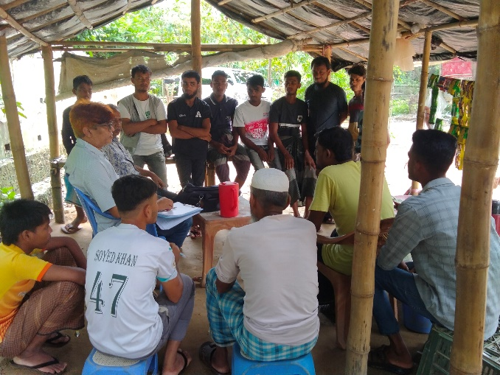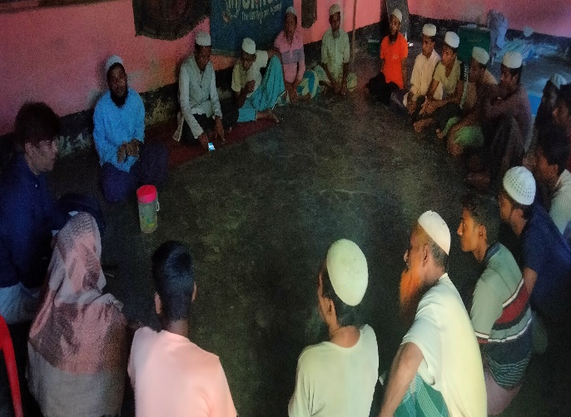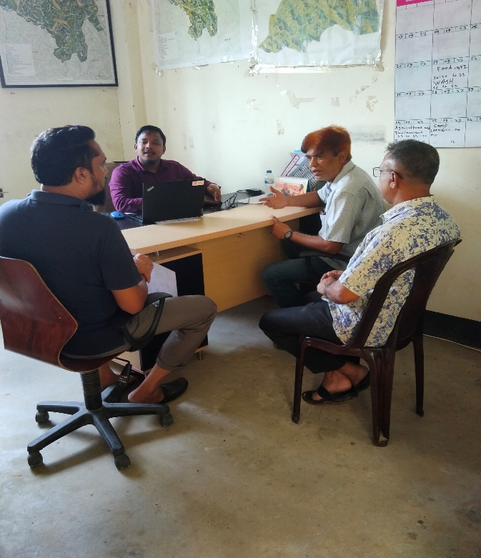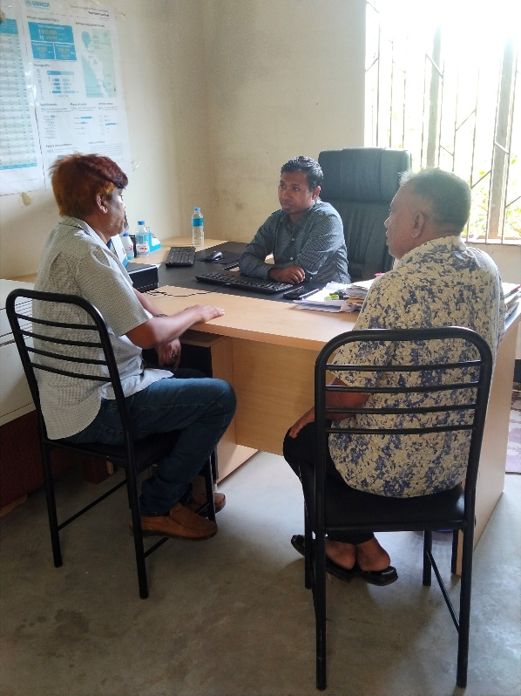

**Figure-02: Consultation Meeting of HHT at camp-17**

**Appendix 03: List of the Participants:**

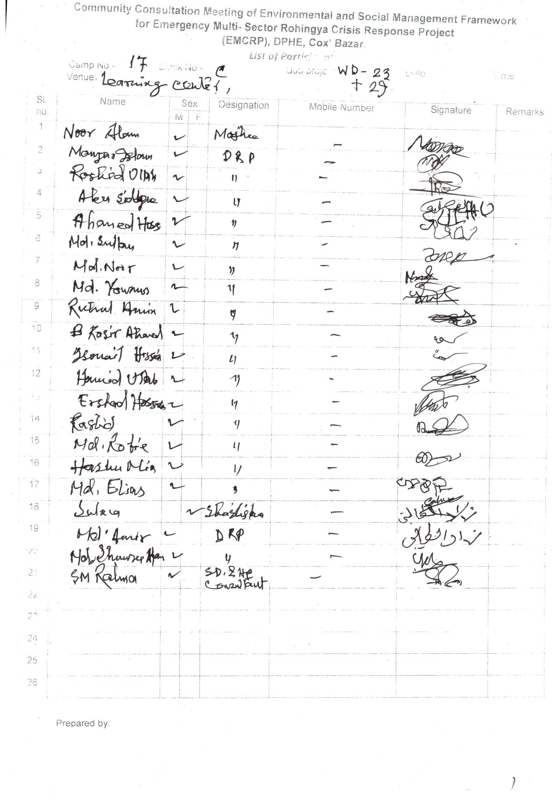

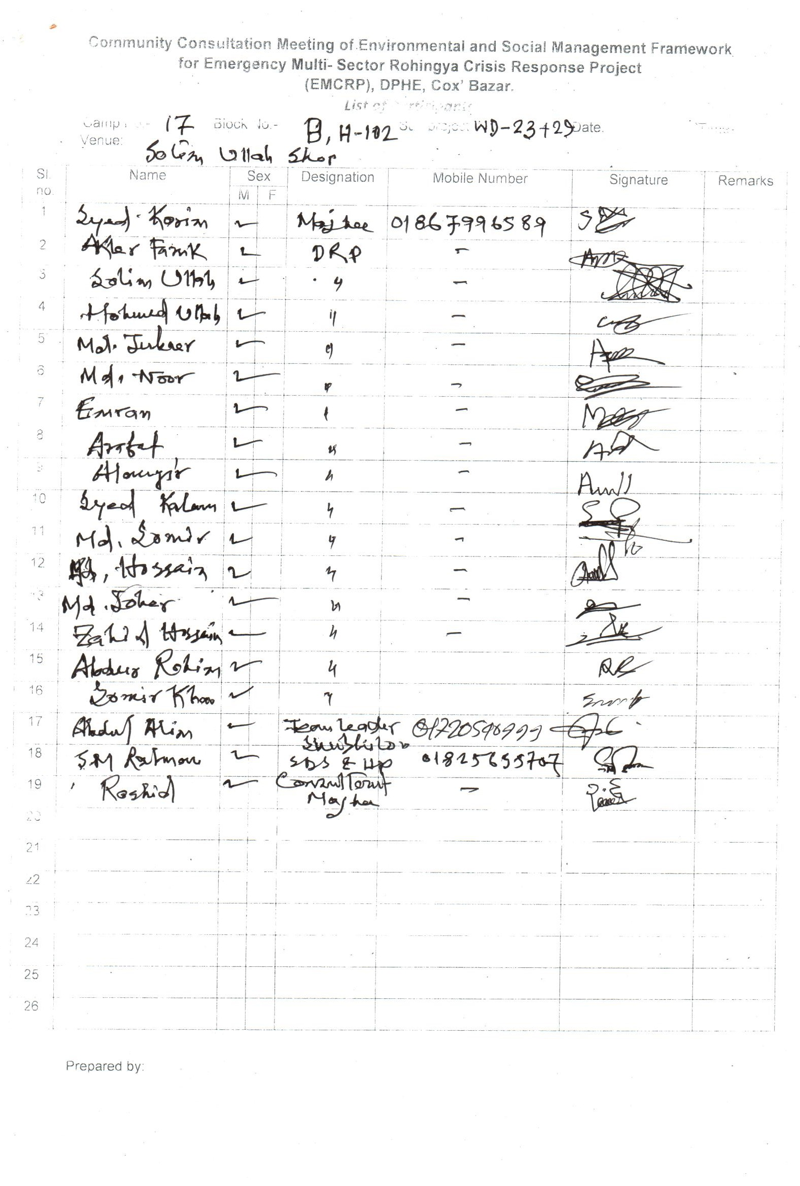

Appendix- 04: Typical design of HH toilet

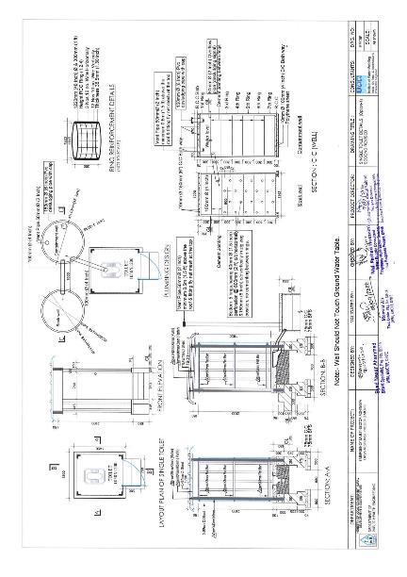

**Appendix-05: Labor's Code of Conduct (CoC):**

**Agreement/Terms of Reference**

Location:

Contracting Organization:

I am . . . . . . . . . . . . . . . . . .. undertake to abide by the following orders, instructions and prohibitions at all times while working at the site.

1. Always treat all local communities with courtesy, courtesy and respect.

2. Under no circumstances will create any kind of relationship with local women, children.

3. Will not take any kind of help or assistance from local people intentionally or unintentionally.

4. Under no circumstances shall give any assurance or undertaking to the local people.

5. Will not harm animals, plants and the environment at work.

6. Always wear and use safety clothing and equipment at work.

7. Always display and save ID Card in the work place.

8. Under no circumstances will indulge in any kind of anti-social activities and any kind of disputes with local people.

9. In case of taking any emergency decision will prior discuss with concerned officer.

If any exception to the above matters occurs or occurs, then I will be obliged to accept the legal punishment or solution taken by the administration in this regard.

…………………….

Signature and Date

**What must be kept in the project site are as follows:**

1. List of workers and officers

2. Attendance Register

3. Leave Register

4. Register for recording details of accidents

5. Register for recording complaints

6. Contract Related particulars

7. In case of emergency contact mobile numbers with names and designations of at least 2 officials shall be displayed in large letters in Bengali and English at visible place.

8. For emergency contact with nearest hospital, police station and doctor their mobile/telephone number shall be displayed at visible place in Bengali and English big letters.

9. Placement of full information and scope of work at work site shall be displayed with a banner at visible place.

10. 20 Ext. Provision of safety signs, warning information and safety fencing shall be provided.

11. Keeping safety materials and equipment and first aid arrangements.

12. Provision of arrangement of car or motor cycle for emergency use.

13. Provision of easily identifiable signs or safety lights at work hazardous places for day and night.

(N.B. The name and location of each organization should be mentioned on the register book)

**Environmental Precautions for the work place:-**

1. No fire shall be ignited unless necessary
2. Animals should never be injured
3. Shall avoid all types of pollution
4. No tree can be cut or damaged without permission
5. Resources should be used appropriately
6. Try to use renewable resource at the best possible way
7. At the end of the work, the previous environment should be in place as much as possible.

**Report Prepared by:**

**Syed Mostamsirur Rahman**

SD & HP Consultant

RPMU, EMCRP (DPHE Part)

Email: [smrahman515@gmail.com](mailto:smrahman515@gmail.com)

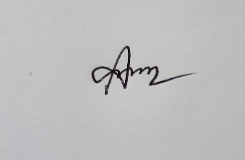

**(Mahbubul Alam)**

Environmental & Hydrogeologist Consultant

RPMU, EMCRP (DPHE Part)

Email: [alam.mahbubgeo@gmail.com](mailto:alam.mahbubgeo@gmail.com)

**Reviewed by:**



**Sarmistha Acharjee**

Deputy Project Director,

EMCRP, DPHE, Cox's Bazar

Email: coxemcrp@gmail.com



**(Md. Muktadir Harun)**

Social Development Officer,

EMCRP, DPHE, Dhaka.

Email: [mh.dphe@gmail.com](mailto:mh.dphe@gmail.com)

**Approved by:**

C:\Users\PC\Desktop\Signature 1.png

**(Mohammad Abdul Kaium)**

Project Director,

EMCRP, DPHE, Dhaka.

Email: [pddphe.emcrp@gmail.com](mailto:pddphe.emcrp@gmail.com)